



SETUP DOCUMENT

LARP EVENT SOFTWARE SOLUTION

Version 2.0

Dholon Akter | Nr. 3047040

Chanelle Hart | Nr. 3323781

Talia Santos | Nr. 3294579

Thanh Hoàng | Nr. 3353362

GROUP 34

# Version History

|  |  |  |  |  |  |
| --- | --- | --- | --- | --- | --- |
| **Version #** | **Implemented By** | **Revision Date** | **Approved By** | **Approval Date** | **Reason** |
| 0.5 | T. Santos | 6th Mar | - | - | Rough draft |
| 0.6 | C. Hart | 9th Mar | - | - |  |
| 1.0 | T. Hoàng | 11th Mar | - | - | Add GUIs, Wireframes, ERD |
| 2.0 | T. Hoàng | 18th Mar | - | - | Finalization |
| 3.0 | T. Santos | 24th Jun | - | - | Touch up, remove old GUI for replacement |
| 4.0 | T.Hoàng | 24th Jun | - | - | Add: Functional requirements, Processes, Class diagrams |

Table of Contents

Agreements 10

Functional Requirements 10

Processes 12

Authentication 12

Checking in to the event 13

Checking out of the event 14

Loaning items 15

Returning items 16

Selling items 16

Searching for records 18

Displaying statistics and data 18

GUI 19

Login forms for all applications 19

Entrance application 19

Manager application 22

Rental Application 25

Entrance application 27

Classes Diagram 28

Participants 28

Ticket 29

Shop 29

Articles 29

Camping 30

ATM Logs 31

Sitemap and Navigation 32

Wireframes 33

Homepage: 33

Story So Far page: 34

Rules page: 35

Events page 36

Activities page: 37

Food, drinks and loaning items page 38

Games page: 39

Camping page: 40

News page: 41

News – read more: 42

About page: 43

Login page: 44

Sign up page: 45

Participant’s information page 46

Participant’s information page 47

Camping registration page: 48

Bundles page: 49

Visual Design 50

Homepage: 50

Story So Far: 51

Rules page: 52

Events page 53

Activities page: 54

Food, drinks and loaning items page 55

Games page: 56

Camping page: 57

News page: 58

News – read more: 59

About page: 60

Login page: 61

Sign up page: 62

Participant’s information page 63

Participant’s information page 64

Camping registration page: 65

Bundles page: 66

ERD 67

# Agreements

**Applications:**

* The applications should have functionalities supporting the management and personnel of the events.
* The applications will run on Windows.
* The applications should be user-friendly and accessible to all personnel and management.
* The applications for stores and loan stands should be self-service.

**Website:**

* The website should have functionalities supporting the purchase tickets and/or reservations of camping spots.
* The website should be visually appealing and informative to potential visitors.
* All personal information on the website will be carefully stored.
* The website will be able to run on mobile devices.

# Functional Requirements

*Table 1. Functional requirements classified.*

|  |  |  |  |  |
| --- | --- | --- | --- | --- |
|  | **Must have** | **Should have** | **Could have** | **Won’t have** |
| **Website** | [WMH1] Website is informative  [WMH2] Website has visual appeal  [WMH3] User can purchase tickets  [WMH4] User can reserve camps  [WMH5] Website stores information safely | [WSH1] Website is responsive on mobile devices | [WCH1] Website can have an about page for the company  [WCH2] Website can have an about page for the events  [WCH3] Website can have room for feedback  [WCH4] Website can have links to social media  [WCH5] Website can have a picture gallery | [WWH1] Website will not process payments |
| **Applications** | [AMH1] Application can monitor visitors: enter, exit and quantity  [AMH2] Application supports selling and loaning items  [AMH3] User can have an overview of the event  [AMH4] Application can handle ATM logs  [AMH5]  Application can run on Windows | [ASH1] Application is user-friendly  [ASH2] Application have manuals | [ACH1] A mobile application for stores and loan stands |  |

# Processes

There are various processes going on between the application and the database as well as the user and the application. In this section, the processes are presented and analyzed.

The main process is the process which takes care of the main function of the application. The optional features are the functionalities which the user may choose to utilize or not by clicking a button.

The processes are classified into three categories:

1. User ↔ Application: mainly concerned with GUI processes and how the user is notified.
2. Application **→** Database: mainly concerned with what the application requests from the database and how the application handles retrieved data internally.
3. Application **←** Database: mainly concerned with what the database is doing in response to the application’s requests.

### Authentication

#### Main process

Before accessing any of the provided applications, the user has to log in with their credentials.

The process is as follows:

|  |  |  |
| --- | --- | --- |
| **Steps** | **Category** | **Details** |
| **1** | User ↔ Application | User enter credentials |
| **2** | Application **→** Database | If the username is “admin”, query the database |
| **3** | Application **←** Database | Return number of rows with matching username and password |
| **4** | Application **→** Database | If the row number is 1, then the credentials are valid. If not, the credentials are invalid |
| **5** | User ↔ Application | User is notified of the result |

*Figure 1. Authentication process*

If the user logs in successfully, the main form of the application will be displayed. Otherwise, the user remains in the login form.

For applications to be used at a shop, the login’s username defines the shop. Namely: if the username is “loan7” then the shop using it is a loan stand with id number 7. This will define the items and the shop’s information to be displayed in the main application.

An extra procedure is taken for the shop applications. On successful login:

* Extract id number from username
* Retrieve data from the database with said id
* Initialize intermediate Shop object
* Initialize main form with that object

### Checking in to the event

#### Main process

To successfully check in, the user has to first scan their QR code. The QR will have the ticket number encoded in it.

The scanning QR process is as follows:

|  |  |  |
| --- | --- | --- |
| **Steps** | **Category** | **Details** |
| **1** | User ↔ Application | User press button to start QR scanner (a webcam, in this case) |
| **2** | Application **→** Database | The application turns on webcam |
| **3** | User ↔ Application | User positions their QR code against the scanner |
| **4** | Application **→** Database | The application tries to decode the QR |
| **5** | User ↔ Application | A message is displayed accordingly |

*Figure 2.1 Scanning QR process*

If a QR is found, the ticket validation process is as follows:

|  |  |  |
| --- | --- | --- |
| **Steps** | **Category** | **Details** |
| **1** | Application **→** Database | Extracts ticket number from QR. Queries the database for ticket’s information |
| **2.1** | Application **←** Database | Returns ticket information with the given number |
| **2.2** | Application **→** Database | Registers ticket to intermediate Ticket object |
| **2.3** | Application **→** Database | Queries database for the Visitor with said ticket |
| **2.4** | Application **←** Database | Return visitor’s information |
| **2.5** | Application **→** Database | Registers visitor’s information to intermediate Visitor object |
| **3.1.1**  **(for paid tickets)** | User ↔ Application | Application displays ticket and statuses:   * Ticket not found: NOK * Not paid: NOK * Paid: OK |
| **3.1.2** | User ↔ Application | User scans RFID card to link |
| **3.1.3** | Application **→** Database | Registers data to intermediate Visitor object. Updates the database. |
| **3.1.4** | Application **←** Database | Register ticket’s entry time Registers visitor’s RFID and status as checked in |
| **3.2.1**  **(for unpaid tickets)** | User ↔ Application | User can choose to change the ticket’s status |
| **3.2.2** | Application **→** Database | Registers data to intermediate Ticket object. Updates the database. |
| **3.2.3** | Application **←** Database | Register tickets as paid |
| **3.2.4** | User ↔ Application | Application displays retrieved data onto labels |

*Figure 2.2 Ticket validation process*

#### Optional features

The application responsible for checking in also offers the following features:

1. View visitor’s details.

This was made optional due to the fact that in most cases, checking in should be successful. There would not be a constant need of displaying the visitor’s personal details. Should they choose to view the information, the information is retrieved from the visitor’s object and displayed.

1. Check history

If the ticket has already been used, there is an option to check for any transactions made by the owner of said ticket. This feature is implemented for control purposes.

|  |  |  |
| --- | --- | --- |
| **Steps** | **Category** | **Details** |
| **1** | User ↔ Application | User presses button |
| **2** | Application **→** Database | Query for number of orders made by the visitor |
| **3** | Application **←** Database | Return number of records found |
| **4.1** | User ↔ Application | User sees QR code is not in use |
| **4.2** | User ↔ Application | User sees QR code is in use |

*Figure 2.3 Process of checking visitor’s history*

This feature is reserved for supervisors. When overriding, the user is required to go through authentication again, this time with more restrictions.

When logged in as admin, scanning of any ticket will result in a successful operation.

|  |  |  |
| --- | --- | --- |
| **Steps** | **Category** | **Details** |
| **1** | User ↔ Application | Admin user scans ticket |
| **2** | Application **→** Database | If ticket is unpaid, change status to ensure a successful check-in. Updates intermediate object. Updates database. |
| **3** | Application **←** Database | Registers new ticket’s status. |
| **4** | User ↔ Application | Application displays status as OK |

*Figure 2.4 Overriding check-in process*

### Checking out of the event

#### Main process

The checking out process is as follows:

|  |  |  |
| --- | --- | --- |
| **Steps** | **Category** | **Details** |
| **1** | User ↔ Application | User scans RFID |
| **2.1** | Application **→** Database | Queries the database for visitor’s information with said tag |
| **2.2** | Application **←** Database | Return visitor’s information |
| **2.3** | Application **→** Database | Registers data to intermediate Visitor object |
| **2.4** | Application **→** Database | Queries the database for unreturned items |
| **2.5** | Application **←** Database | Return records of unreturned items (if any) |
| **2.6** | Application **→** Database | The application registers the items into a List<LoanArticle> in the Visitor object |
| **3.1.0** | Application **→** Database | The application evaluates the list of items |
| **3.1.1** | Application **→** Database | The application tells database to check out the visitor |
| **3.1.2** | Application **←** Database | Move visitor’s record to deleted_visitor table |
| **3.1.3** | User ↔ Application | User see status “OK” |
| **3.2.1** | User ↔ Application | User see status “NOK” together with item’s information |

*Figure 3.1 Checking out process*

#### Optional features

The application responsible for checking out also offers the following features:

1. Override

This feature is reserved for supervisors. When overriding, the user is required to go through authentication again, this time with more restrictions.

When logged in as admin, scanning of any RFID will result in a successful check out.

|  |  |  |
| --- | --- | --- |
| **Steps** | **Category** | **Details** |
| **1** | User ↔ Application | Admin user scans ticket |
| **2** | Application **→** Database | Registers intermediate Visitor object as checked out. Updates database. |
| **3** | Application **←** Database | Move visitor’s record to deleted_visitor table |
| **4** | User ↔ Application | User sees “OK” status |

*Figure 3.2 Overriding check-out process*

### Loaning items

#### Main process

To check out, the RFID card of the visitor must first be scanned.

|  |  |  |
| --- | --- | --- |
| **Steps** | **Category** | **Details** |
| **1** | User ↔ Application | User scans RFID card |
| **2** | Application **→** Database | Queries database for visitor with said tag |
| **3** | Application **←** Database | Return visitor’s information |
| **4** | Application **→** Database | Registers information to intermediate Visitor object |

*Figure 4.1 Process of scanning RFID to loan*

After which, a message box will be shown to notify the user that they can now scan the items. The process behind the scanning items to loan is:

|  |  |  |
| --- | --- | --- |
| **Steps** | **Category** | **Details** |
| **1** | User ↔ Application | User scans item |
| **2** | Application **→** Database | Queries database for item with said tag |
| **3** | Application **←** Database | Return item’s information |
| **4** | Application **→** Database | Registers information to intermediate object |
| **5** | User ↔ Application | User picks return date |
| **6.1.1** | User ↔ Application | “Confirm” button once all items are scanned |
| **6.1.2** | Application **→** Database | Evaluates the deposit values of all items scanned |
| **6.2.1**  **(Not enough credit)** | User ↔ Application | User is notified |
| **6.3.1**  **(enough credit)** | Application **→** Database | Credit is being deducted from intermediate object. Formulates SQL to   * Add order * Mark items as loaned * Deducts visitor’s credit   Queries the database with said SQL. |
| **6.3.2** | Application **←** Database | Adds new order record Registers the items as not available Deducts visitor’s credit |
| **6.3.3** | User ↔ Application | User sees “Loan successful!” status |

*Figure 4.2 Process of scanning items to loan*

#### Optional features

* Remove

User can also choose to remove the scanned items out of their loaning list.

|  |  |  |
| --- | --- | --- |
| **Steps** | **Category** | **Details** |
| **1** | User ↔ Application | User selected items in the list, clicks “Remove” button |
| **2** | Application **→** Database | Removes the item from the intermediate objects. |

*Figure 4.3 Process of removing items out of loaning list*

### Returning items

#### Main process

To return the items, the user must first scan their RFID card – a process of which is described in Figure 4.1.

After which, a message box will be shown to notify the user that they can now scan the items. The process behind the scanning items to return is:

|  |  |  |
| --- | --- | --- |
| **Steps** | **Category** | **Details** |
| **1** | User ↔ Application | User scans item |
| **2.1** | Application **→** Database | Queries database for item with said tag. |
| **2.2** | Application **←** Database | Return item’s information. |
| **2.3** | Application **→** Database | Registers information to intermediate object. |
| **3** | Application **→** Database | Calculate credits to return/deduct based on price and deposit value. |
| **4** | Application **→** Database | Formulates SQL to:   * Mark item as returned * Change visitor’s credit   Queries the database. |
| **5** | Application **←** Database | Items are registered as available.  Visitor’s credit is changed |
| **6** | User ↔ Application | User sees status signifying successful return.  User is notified with the item’s information as well as credits being returned/deducted |

*Figure 5 Process of scanning items to return*

### Selling items

To sell items, the application must firs load the available items from the database.

Since the application also supports the loading of pictures onto appropriate buttons, the application prepares for this by:

* The buttons which will hold the images are named with a prefix “productButton”
* Initialize a list of buttons to load the pictures on
* Cycle through all available buttons in the application and add the ones with the prefix “productButton” to the list

A similar process is done to the labels. By now, the application will have a way of accessing the appropriate labels and buttons to load the information to.

|  |  |  |
| --- | --- | --- |
| **Steps** | **Category** | **Details** |
| **1** | Application **→** Database | Queries database for all available items |
| **2** | Application **←** Database | Return item’s information |
| **3.1** | Application **→** Database | Store items in intermediate list |
| **3.2** | Application **→** Database | Sort list by Category |
| **3.3** | Application **→** Database | Extract image’s filename from the items and load it to the button Change button’s background color based on Category. |
| **3.4** | Application **→** Database | Extract item’s name and load it to the label |

*Figure 6.1 Process of loading item’s information to application*

The user can then click on a button to add it to their order.

|  |  |  |
| --- | --- | --- |
| **Steps** | **Category** | **Details** |
| **1** | User ↔ Application | User presses item’s button |
| **2** | Application **→** Database | Extract proper index based on the button’s name |
| **3** | Application **→** Database | Update intermediate order object |

*Figure 6.2 Process of adding items to order*

There is also the option to add or remove the quantity – one which functions similar to the remove feature in Figure 4.3.

After the user is certain with their order, they can press the “Confirm” button to finalize the payment. On press, the application will await a scan of the RFID.

When the card is scanned, the following process is carried out and the order is marked as complete.

|  |  |  |
| --- | --- | --- |
| **Steps** | **Category** | **Details** |
| **1** | User ↔ Application | User scans RFID card |
| **2** | Application **→** Database | Query database for visitor with said tag |
| **3.1** | Application **←** Database | Return visitor’s information |
| **3.2** | Application **→** Database | Register information to intermediate visitor object |
| **4** | Application **→** Database | Deduct credit to visitor object.  Formulate SQL to handle order. |
| **5** | Application **→** Database | Query database |
| **6** | Application **←** Database | Deduct item’s quantity Deduct credit  Add a new order record |
| **7.1** | User ↔ Application | User is notified of successful order |
| **7.2** | Application **→** Database | Intermediate objects are reset for new order |

*Figure 6.3 Process of handling order*

### Searching for records

This process is used in all of the Logs section of the applications to search through the database with specified criteria.

For searching in the database’s information, the procedure can be generalized to be as follows:

|  |  |  |
| --- | --- | --- |
| **Steps** | **Category** | **Details** |
| **1** | User ↔ Application | User specified what to search and search data |
| **2** | Application **→** Database | Query database |
| **3.1** | Application **←** Database | Return information |
| **3.2** | Application **→** Database | Register information to intermediate object(s) |
| **4** | User ↔ Application | Application displays data for users to see |

*Figure 7 Process of handling a search request*

### Displaying statistics and data

This process is used in the Manager’s application to display data and statistics. The processes are similar to one another and can be summed up as follows.

For displaying data:

|  |  |  |
| --- | --- | --- |
| **Steps** | **Category** | **Details** |
| **1** | User ↔ Application | User specified what data to display |
| **2** | Application **→** Database | Query database |
| **3.1** | Application **←** Database | Return information |
| **3.2** | Application **→** Database | Build data tables based on information |
| **4** | User ↔ Application | Application loads data to grid views for user to see |

*Figure 8.1 Process of displaying data*

For displaying charts:

|  |  |  |
| --- | --- | --- |
| **Steps** | **Category** | **Details** |
| **1** | User ↔ Application | User specified what data to display |
| **2** | Application **→** Database | Query database |
| **3.1** | Application **←** Database | Return information |
| **3.2** | Application **→** Database | Build data sets based on information |
| **3.3** | Application **→** Database | Formulates charts based on data sets |
| **4** | User ↔ Application | User gets visualization of data |

*Figure 8.2 Process of displaying charts*

# Classes Diagram

The classes are designed to resemble entities in the database, with tweaking to facilitiate storing and retrieving information. They can be thought of as intermediate objects to help with user – database interaction.

When data is retrieved from the database, it will be stored as object of one of the following classes. The objects allow for easier manipulation of data as well as better organization.

This section will present the classes in relation to one another, together with a justification for their design.

## Participants

## C:\Users\yenth\AppData\Local\Microsoft\Windows\INetCache\Content.Word\participantuml.jpg

*Figure 6.1 Participant class and its children*

There are two types of participants at the event: staff and visitors. Both types share the same common information and can be checked in/out of the event – hence, the superclass Participant.

The children class Staff and Visitor holds attributes and methods which are unique to the specified type.

## Ticket

Each visitor coming to the event has a ticket, whose information is stored in the Ticket object.

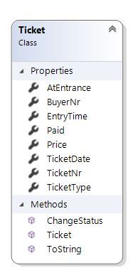

*Figure 6.2 Ticket class*

## Shop

The stores and loan stands are classified as shops and share the same information as follows:

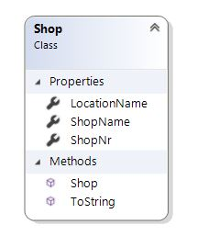

*Figure 6.3 Shop class*

## Articles

Within shops, there are articles. Depending on the shop’s type (a store or a loan stand), the article’s type differs.

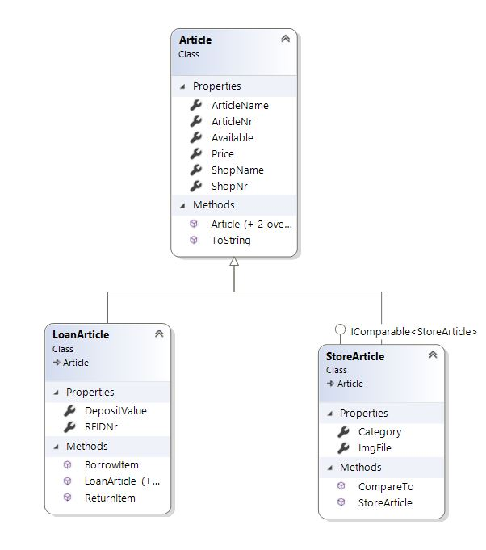

*Figure 6.4 Article class and its children*

All articles share the same basic information which is stored in the Article superclass. Its children holds the unique attributes and method of their type.

## Order

The orders placed at a shop will also be stored.

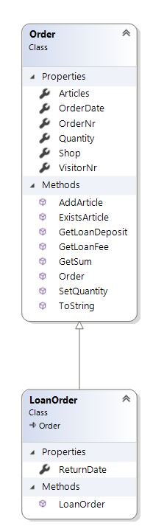

*Figure 6.5 Order superclass and its child*

There is a LoanOrder child class as it holds a ReturnDate which the normal order does not have.

## Camping

The camping spots at the event as well as their reservations will have their information stored in the following classes:

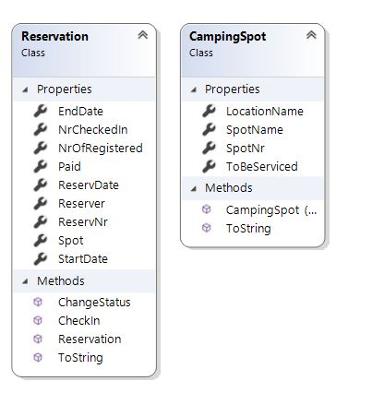

*Figure 6.6 Reservation and CampingSpot classes*

## ATM Logs

It is also required of the applications to be able to transfer logs exported by the bank into the database. To facilitate such process, this class is created.

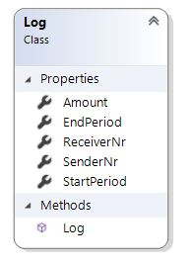

*Figure 6.7 Log class*

# GUI

## Login forms for all applications

All applications require authentication before the user can access the functionalities. Below is how said form would look.

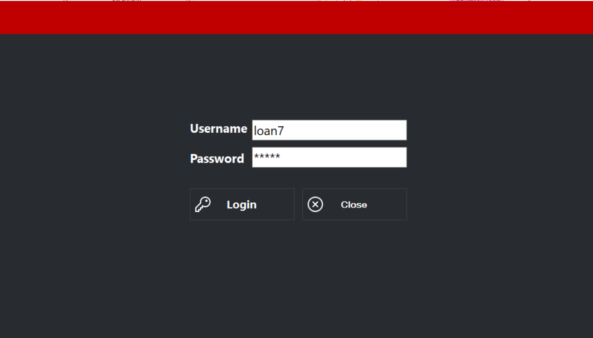

Figure . Login form for all applications

## Entrance application

The entrance application has two sections:

1. Check-in: The section used for scanning and checking in visitors (see Figure 2.1)
2. Logs: The section used to see and/or search relevant data (see Figure 2.2)

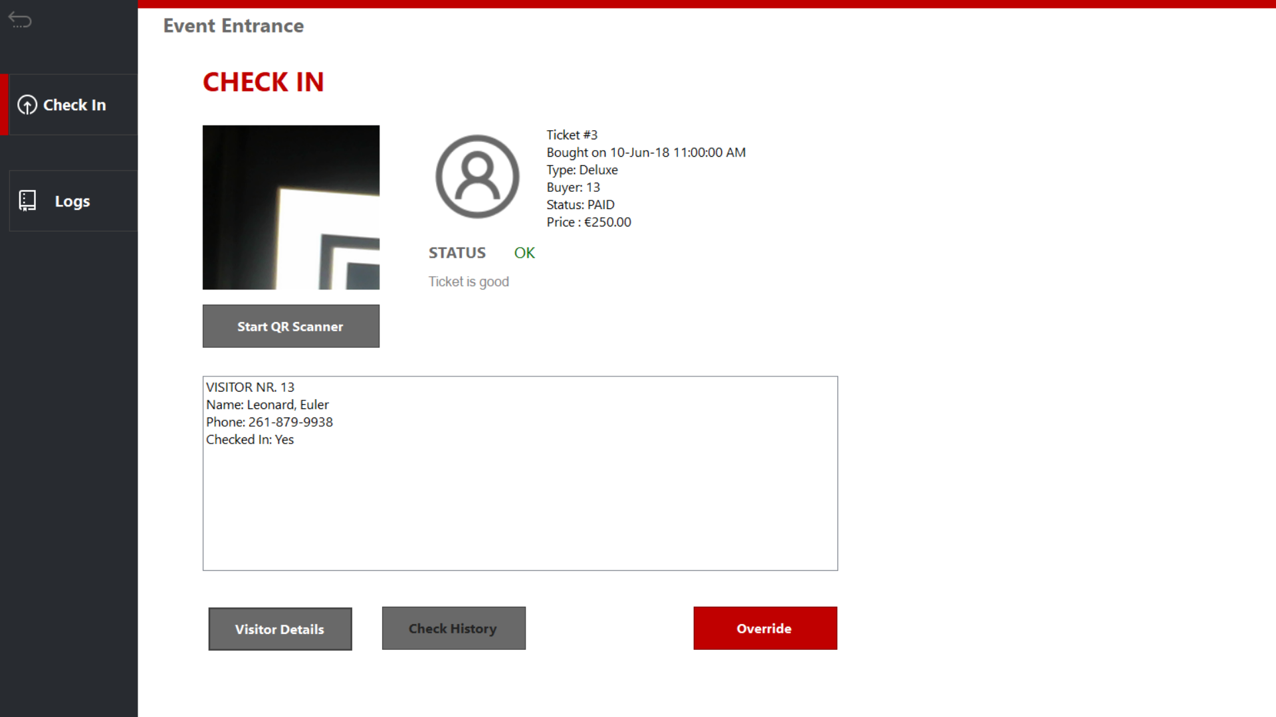

Figure .1 Check-in form for the event

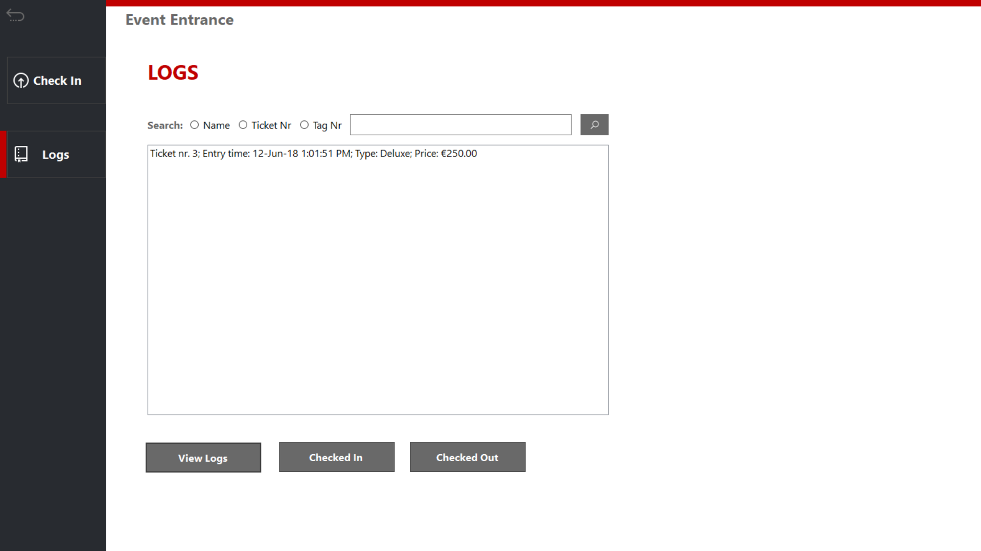

Figure 2.2 Ticket logs for event application

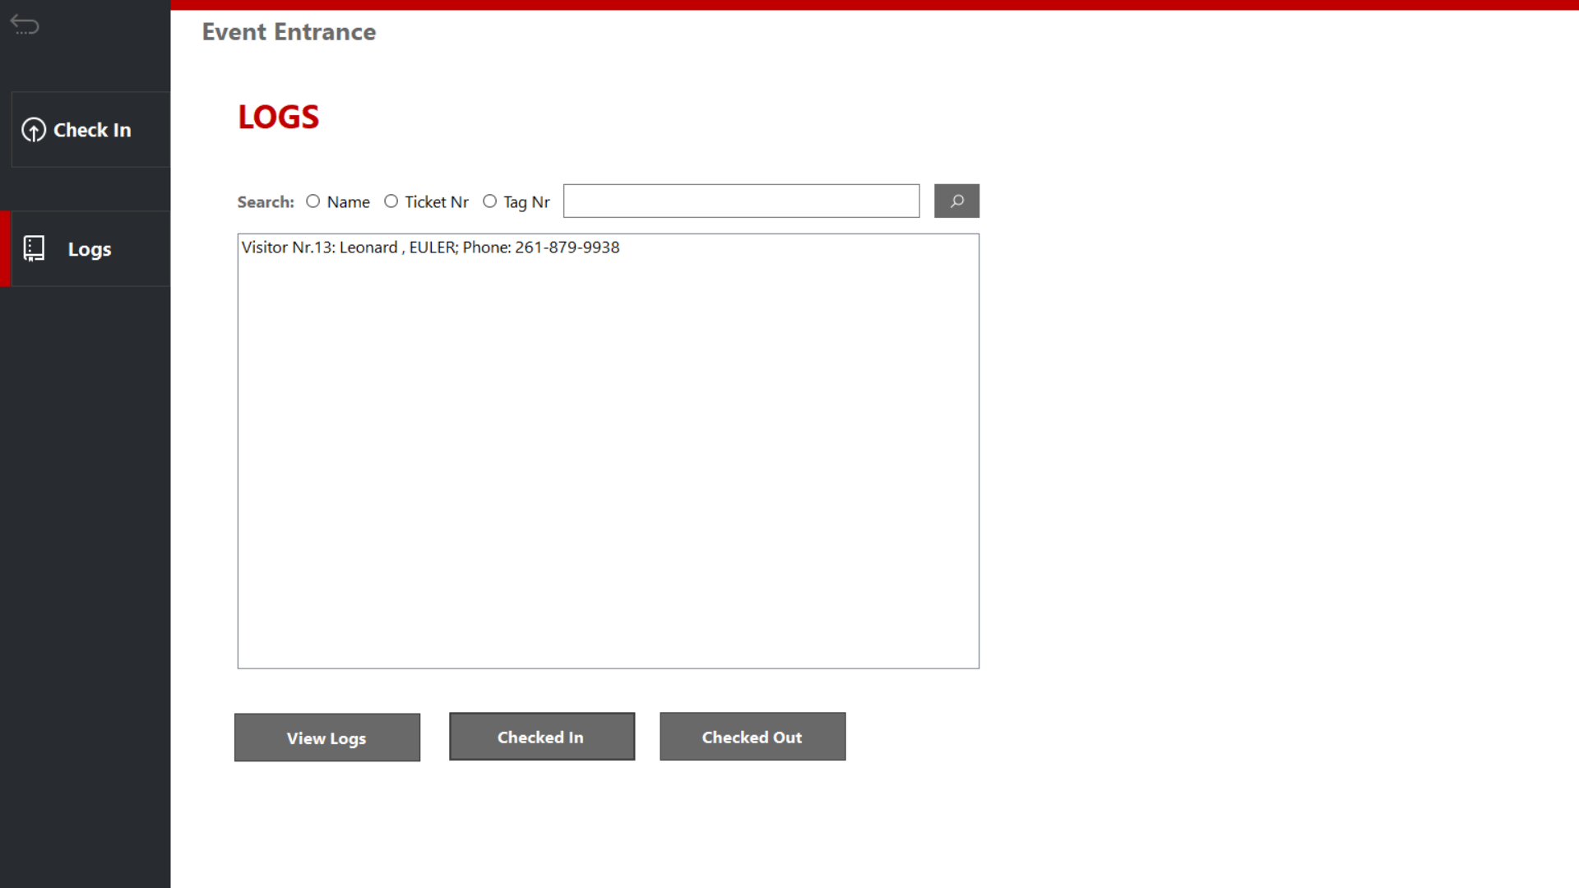

Figure 2.3 Visitor logs for entrance application

## Manager application

Manager has a home section where you can go into several sections, as can be see from the buttons in Figure 3.

1. Visitors: where you can check a variety of data related to people visiting the event (see Figure 3.1)
2. Staff: personnel related data (see Figure 3.2)
3. Camping: campsite related data (see Figure 3.3)
4. Transactions: ATM related logs and data (see Figure 3.4)
5. Logout brings you back to the login form.

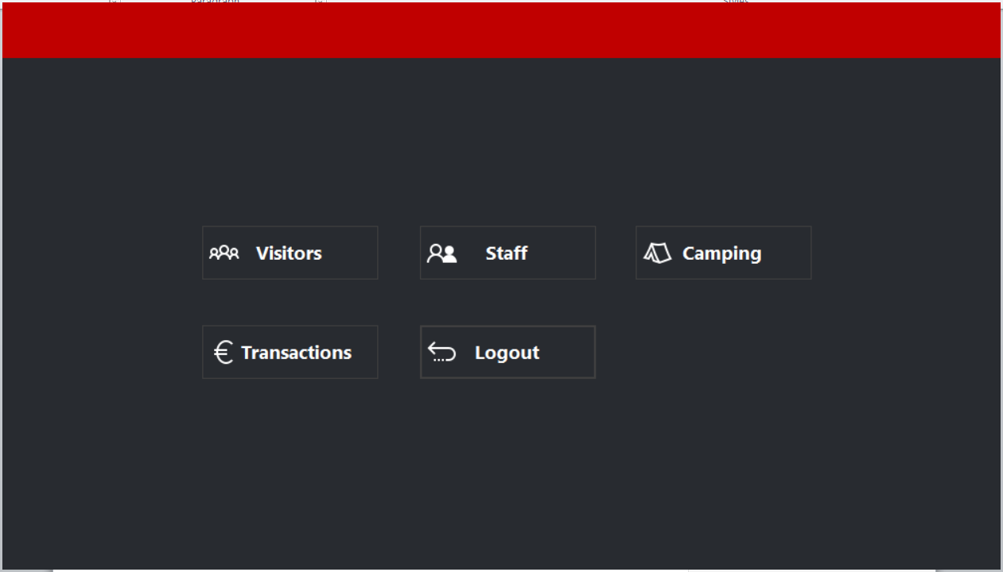

Figure . Home form

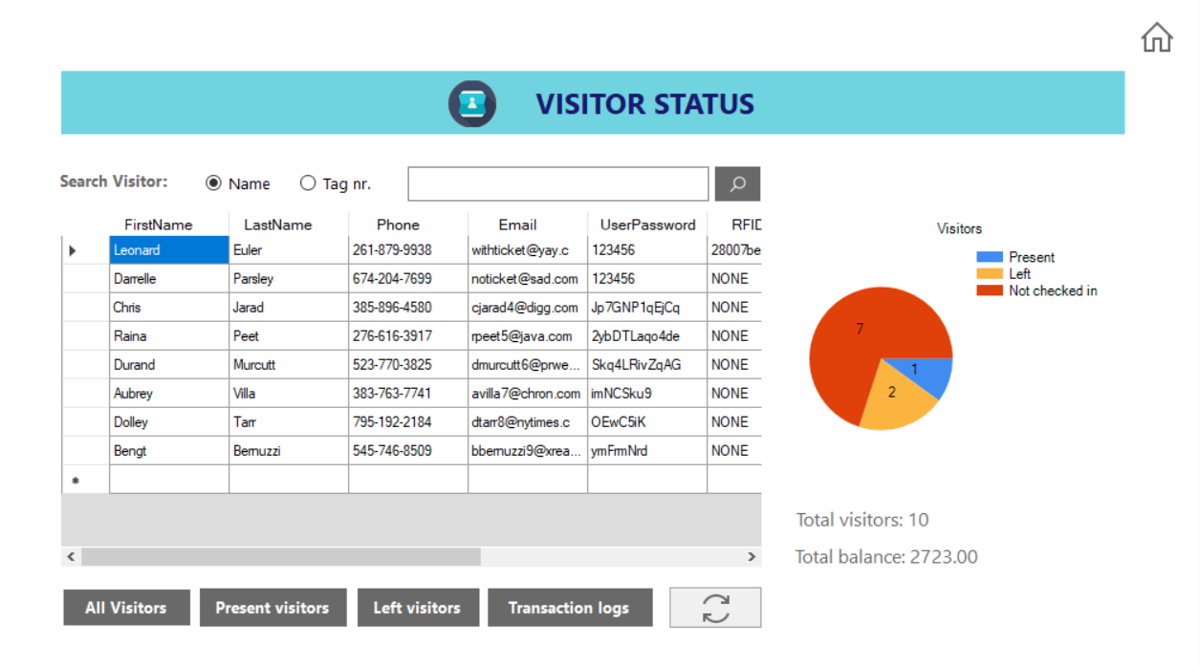

Figure 3.1 Visitor data

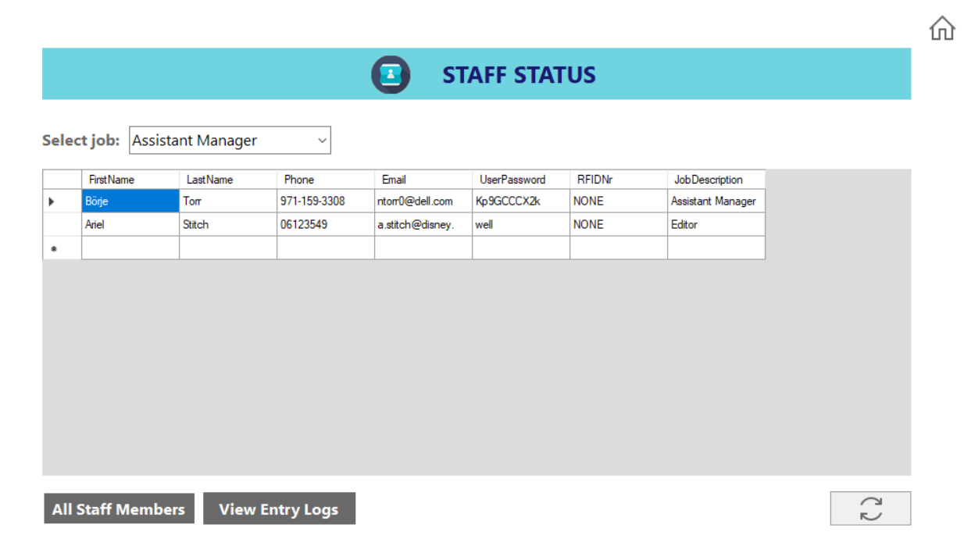

Figure 3.2 Staff data

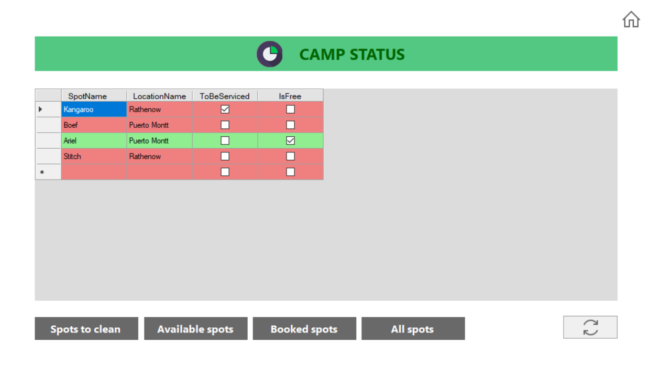

Figure 3.3 Camp data

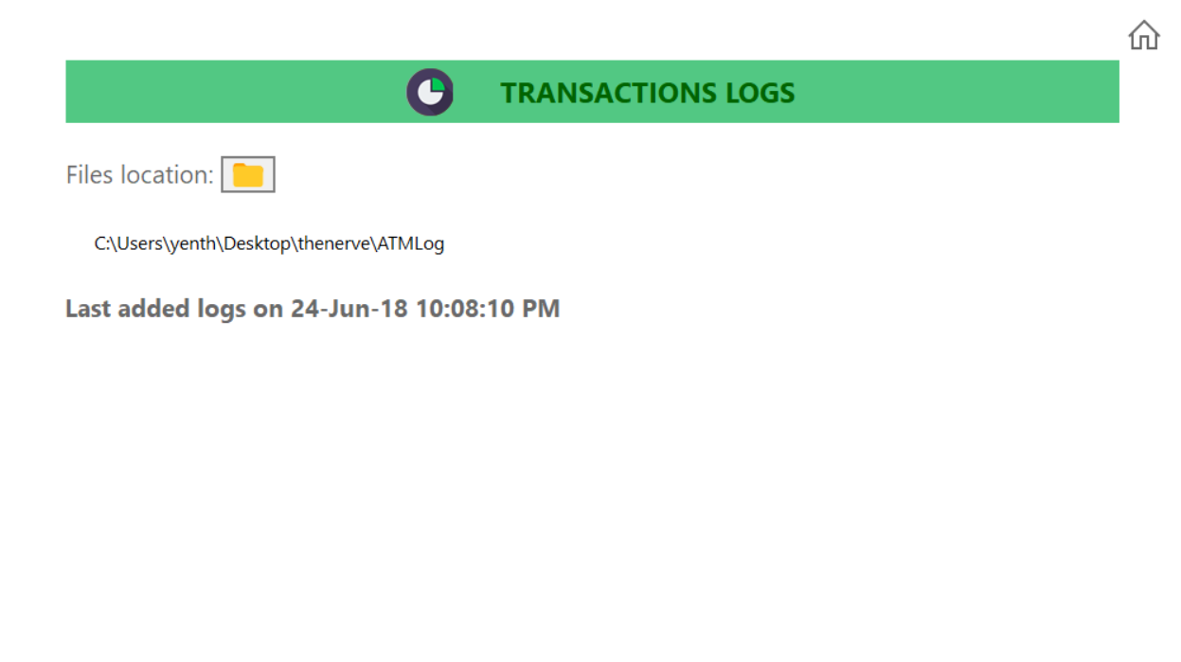

Figure 3.4 Transactions logs

## Rental Application

The rental application has three sections:

1. Loaning: The section used for scanning items that visitors might want to borrow (see Figure 4.1)
2. Returning: Section used for scanning items that visitors are returning (see Figure 4.2)
3. Logs: The section used to see and/or search relevant data (see Figure 4.2)

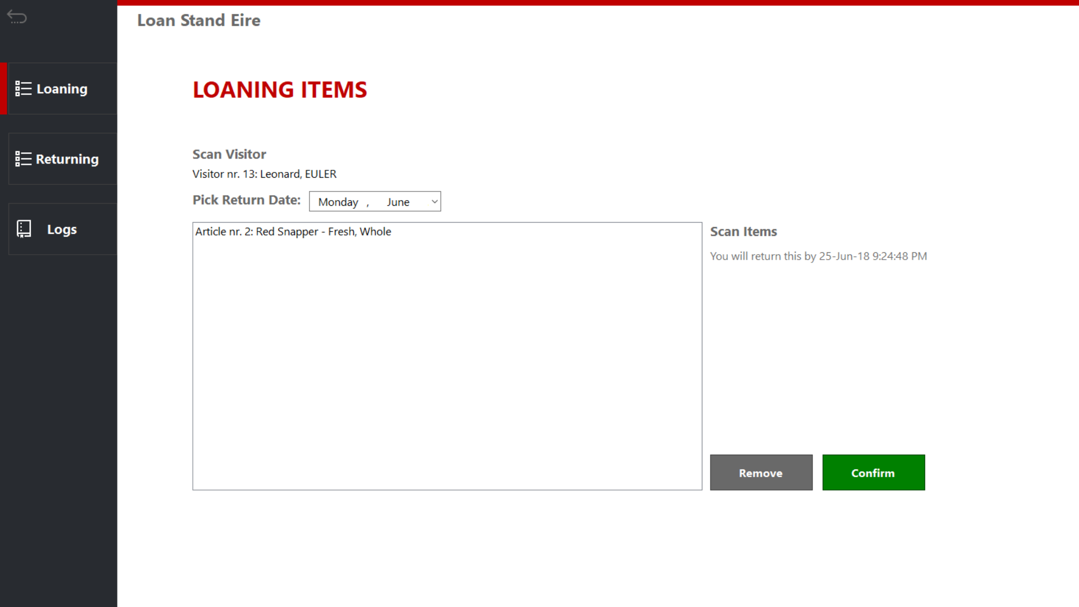

Figure .1 Loan section

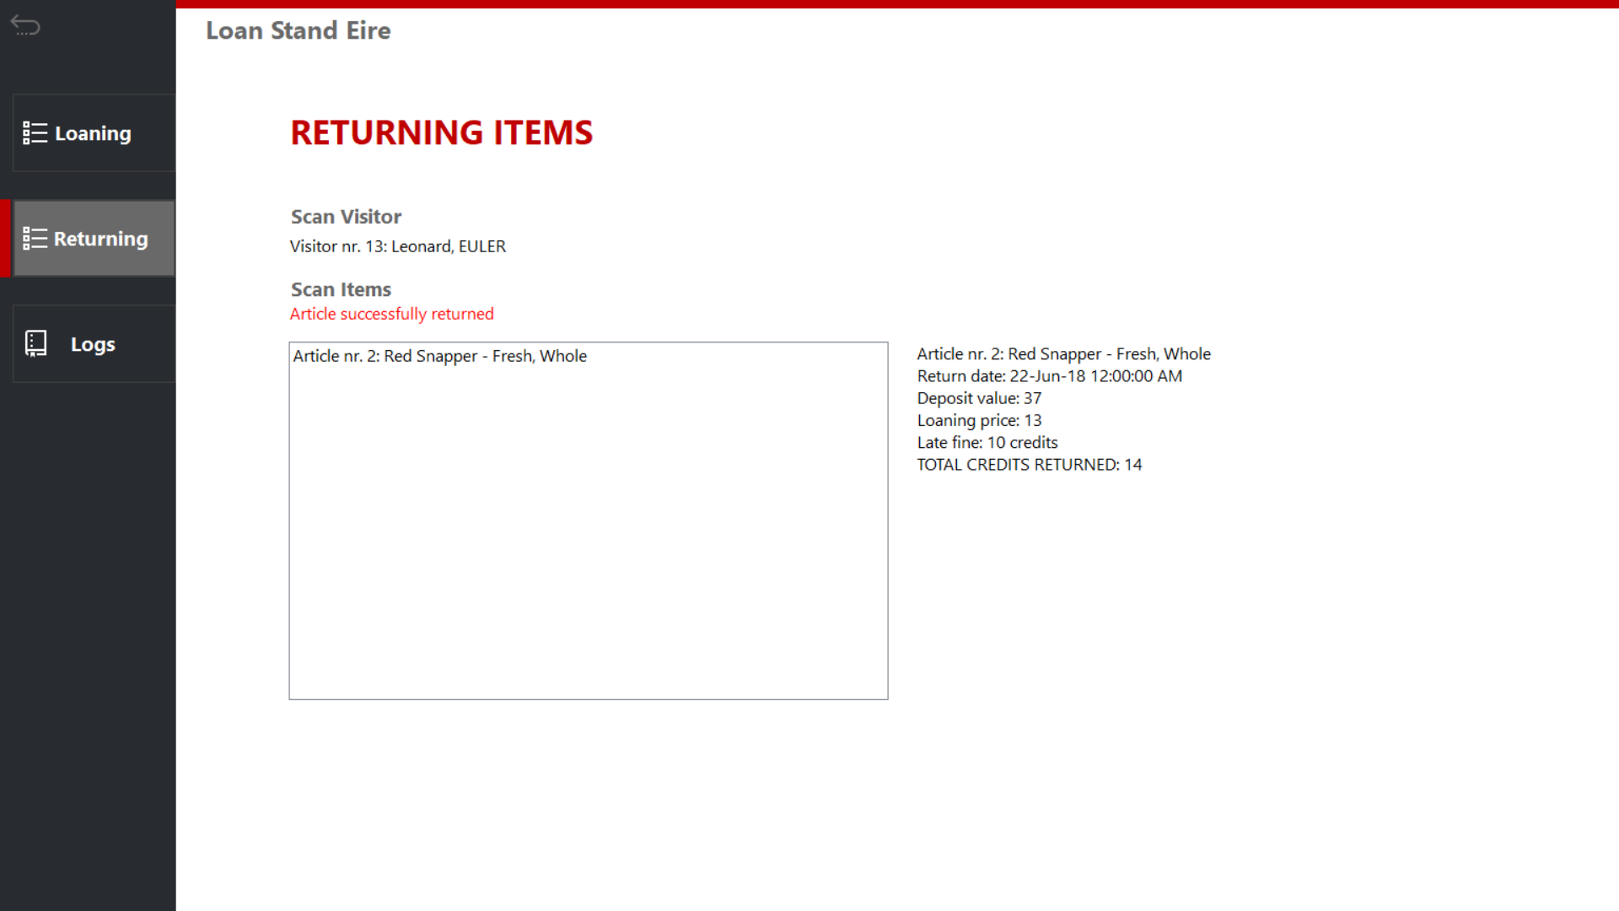

Figure 4.2 Returning items

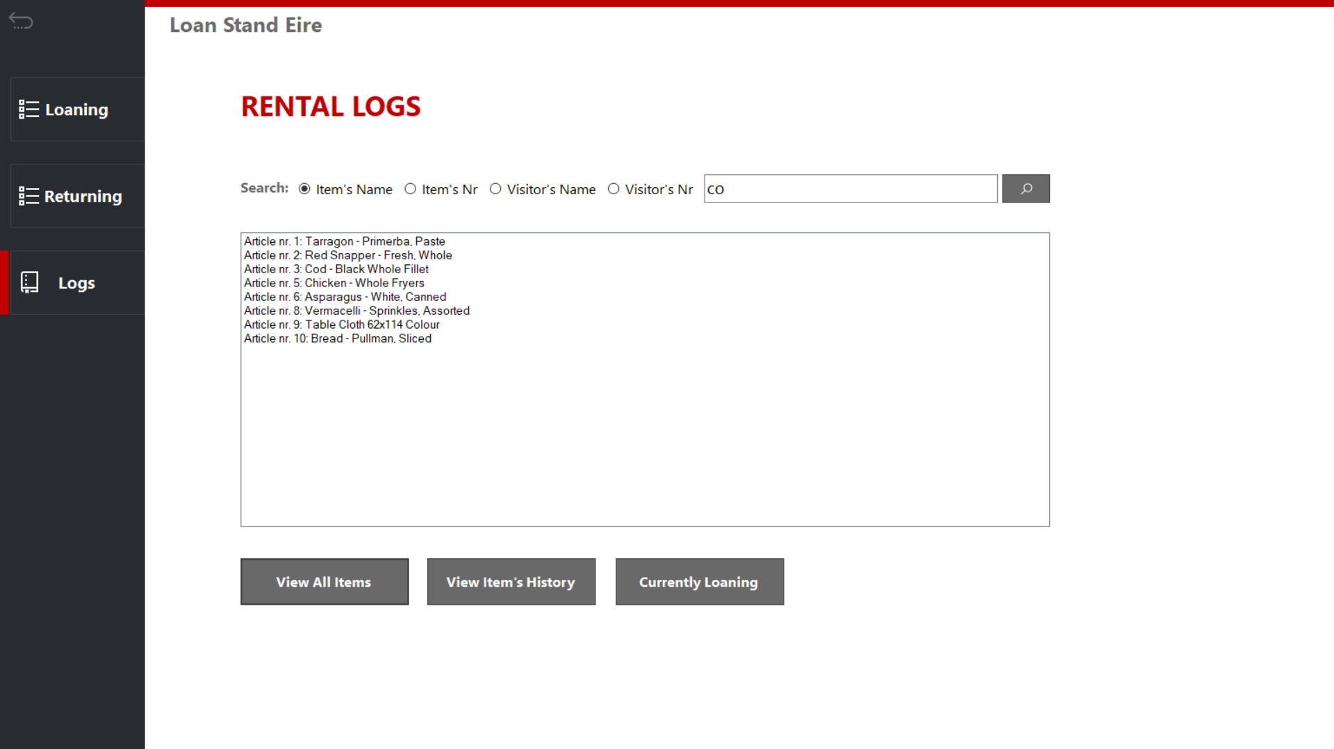

Figure 4.3 Rental logs

## Entrance application

The Store application has two sections:

1. Order: The section used for ordering food or drink items (see Figure 5.1)
2. Logs: The section used to see and/or search relevant data, like stock (see Figure 5.2)

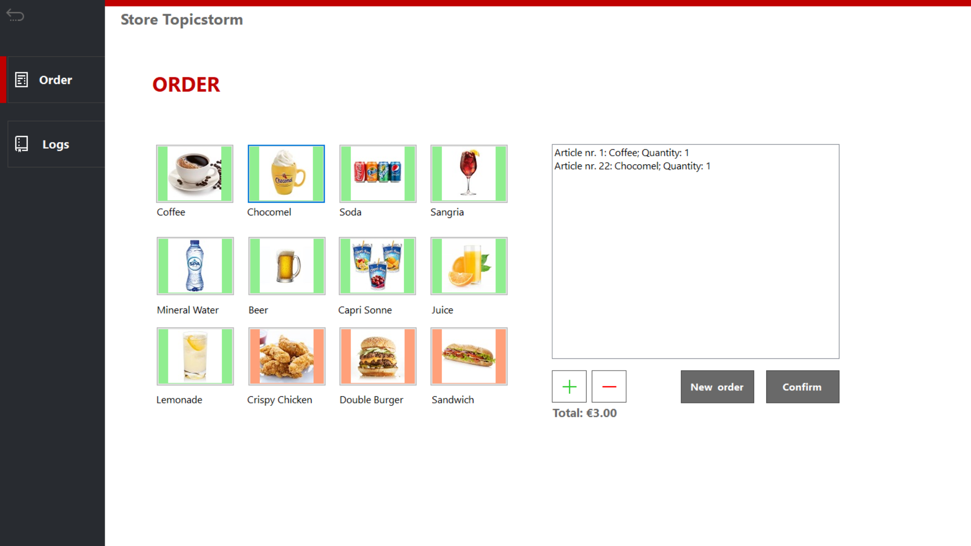

Figure .1 Taking an order

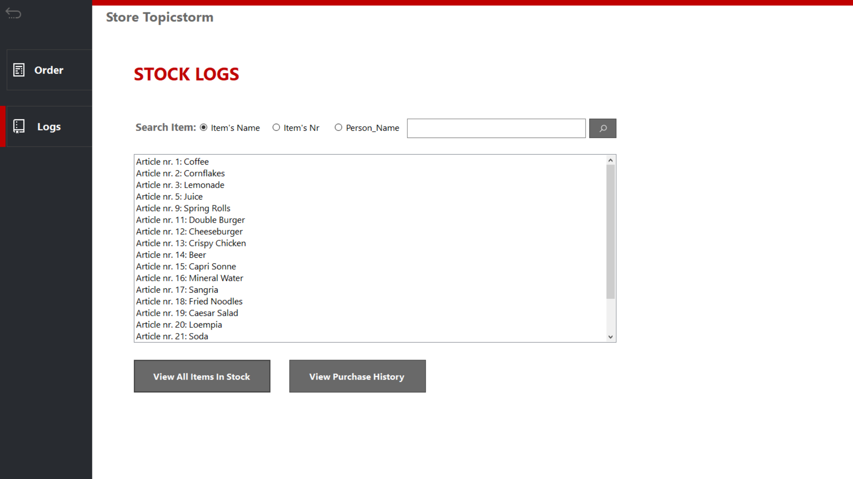

Figure 5.2 Stock logs

# Sitemap and Navigation

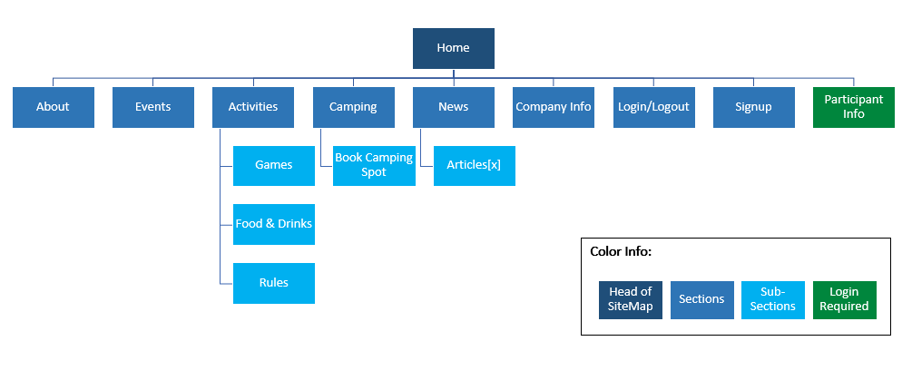

*Figure 7. Sitemap*

# Wireframes

## Homepage:

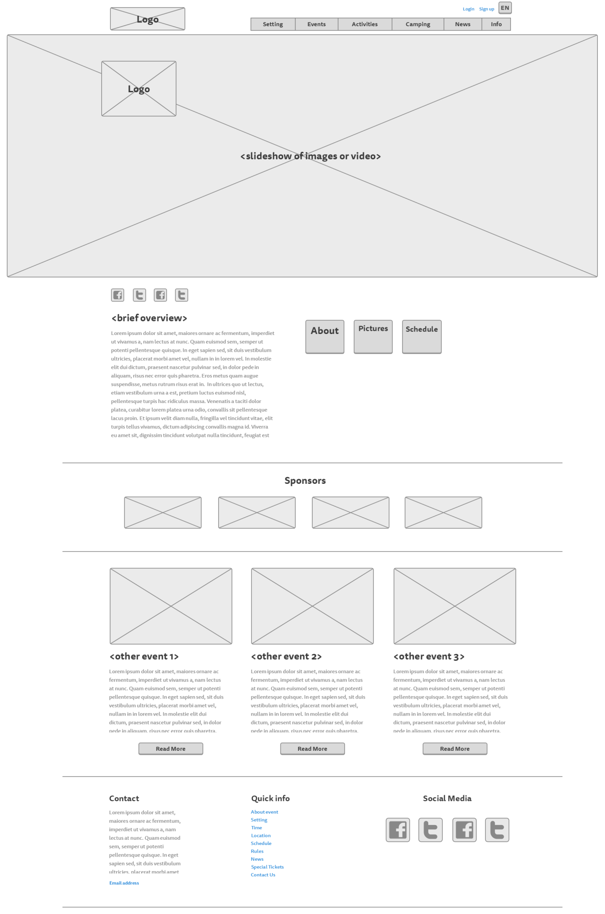

## Story So Far page:

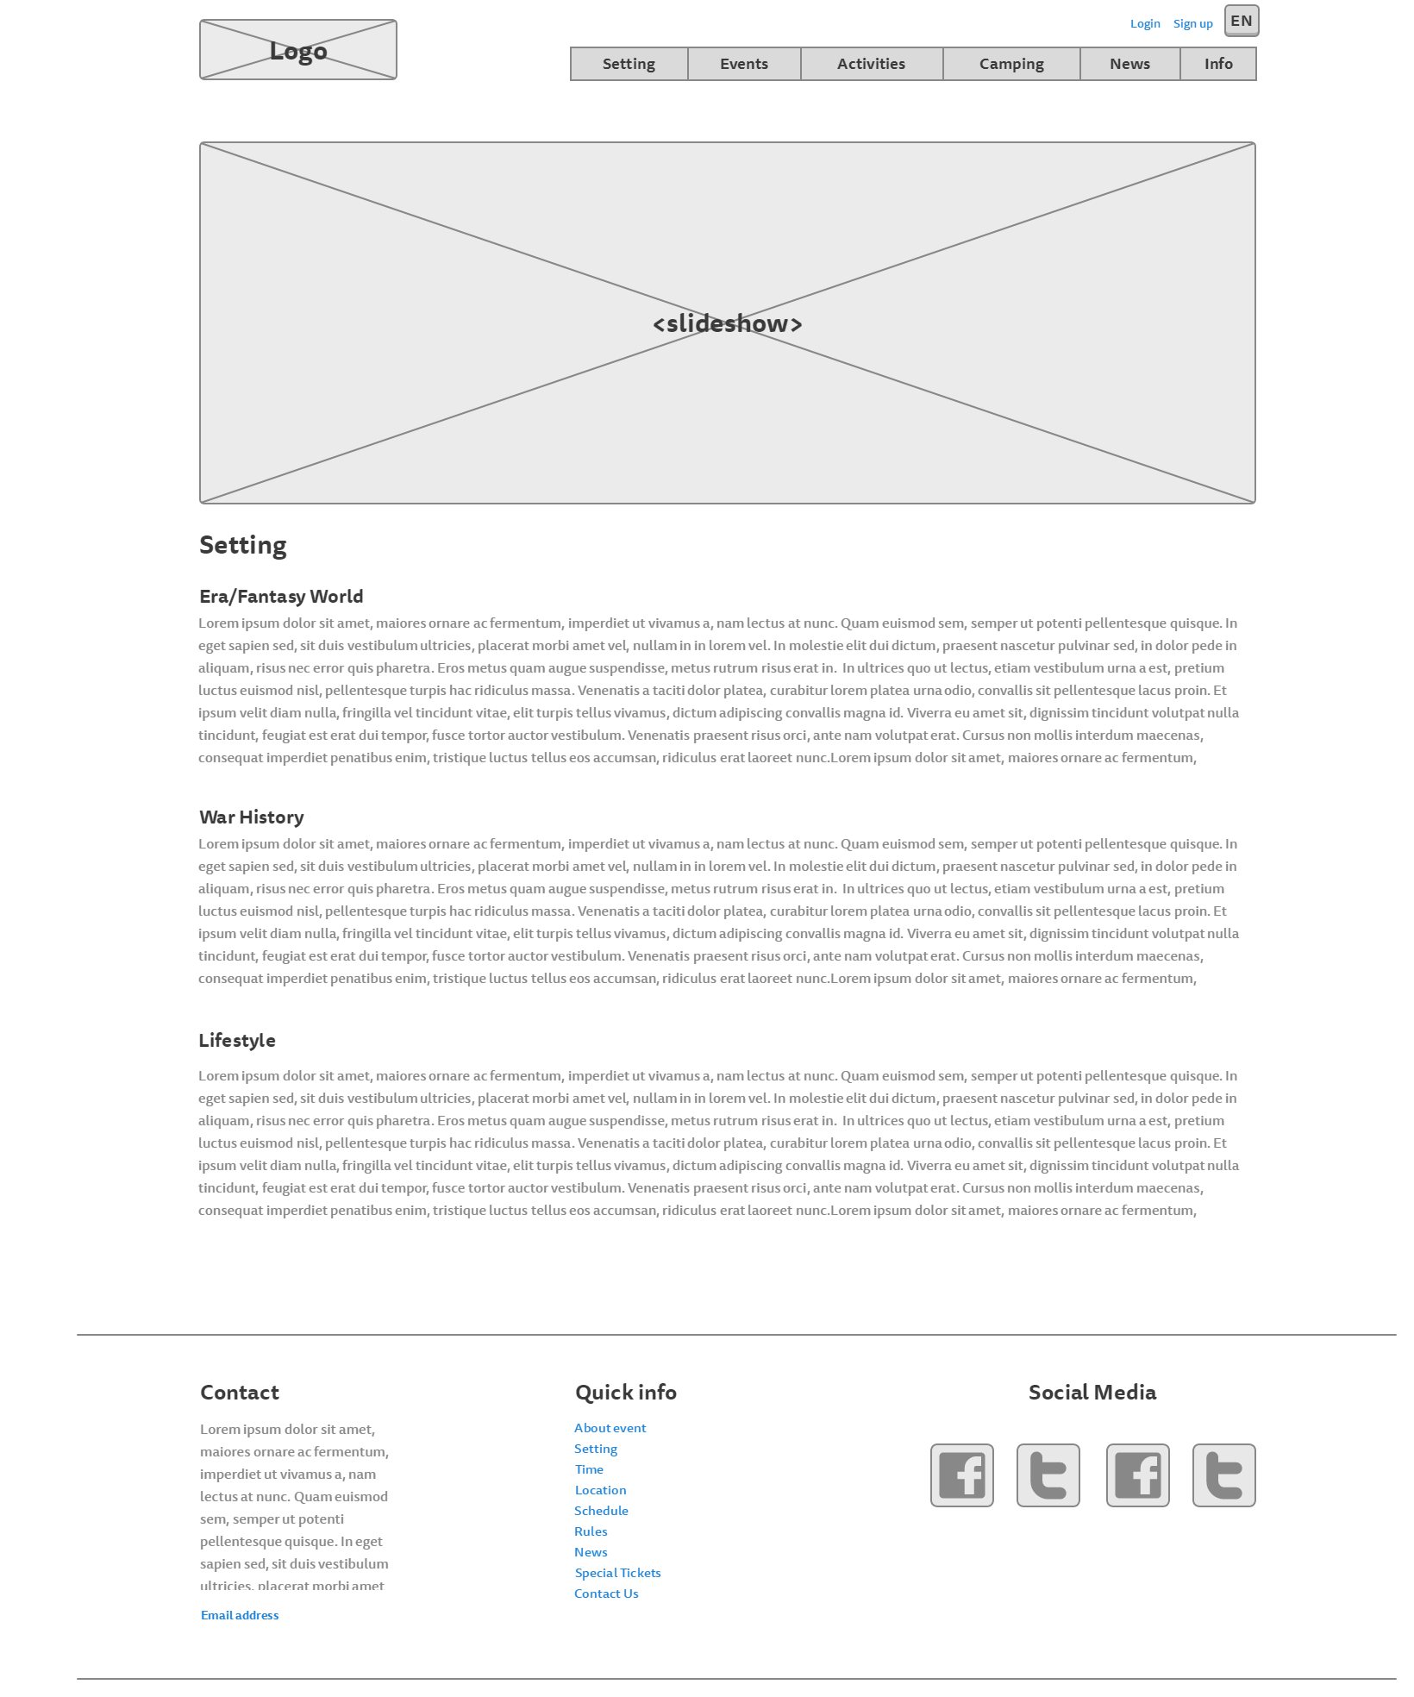

## Rules page:

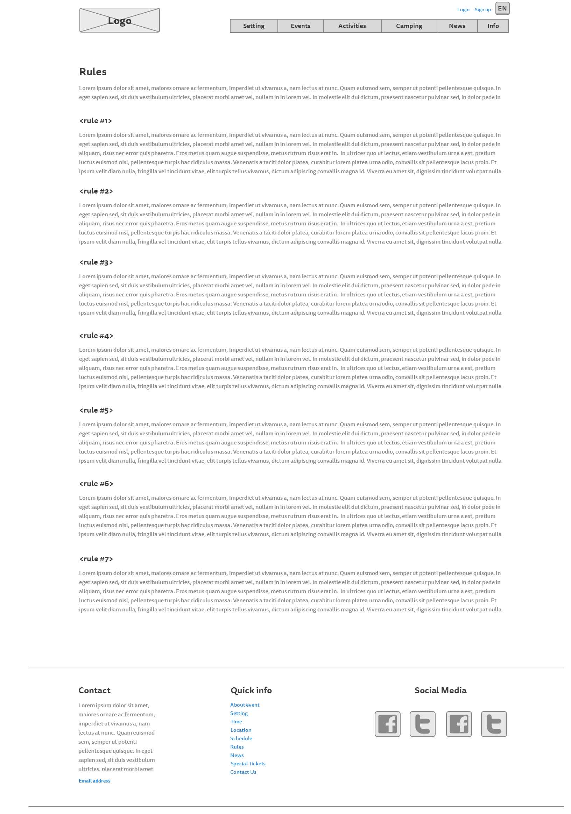

## Events page

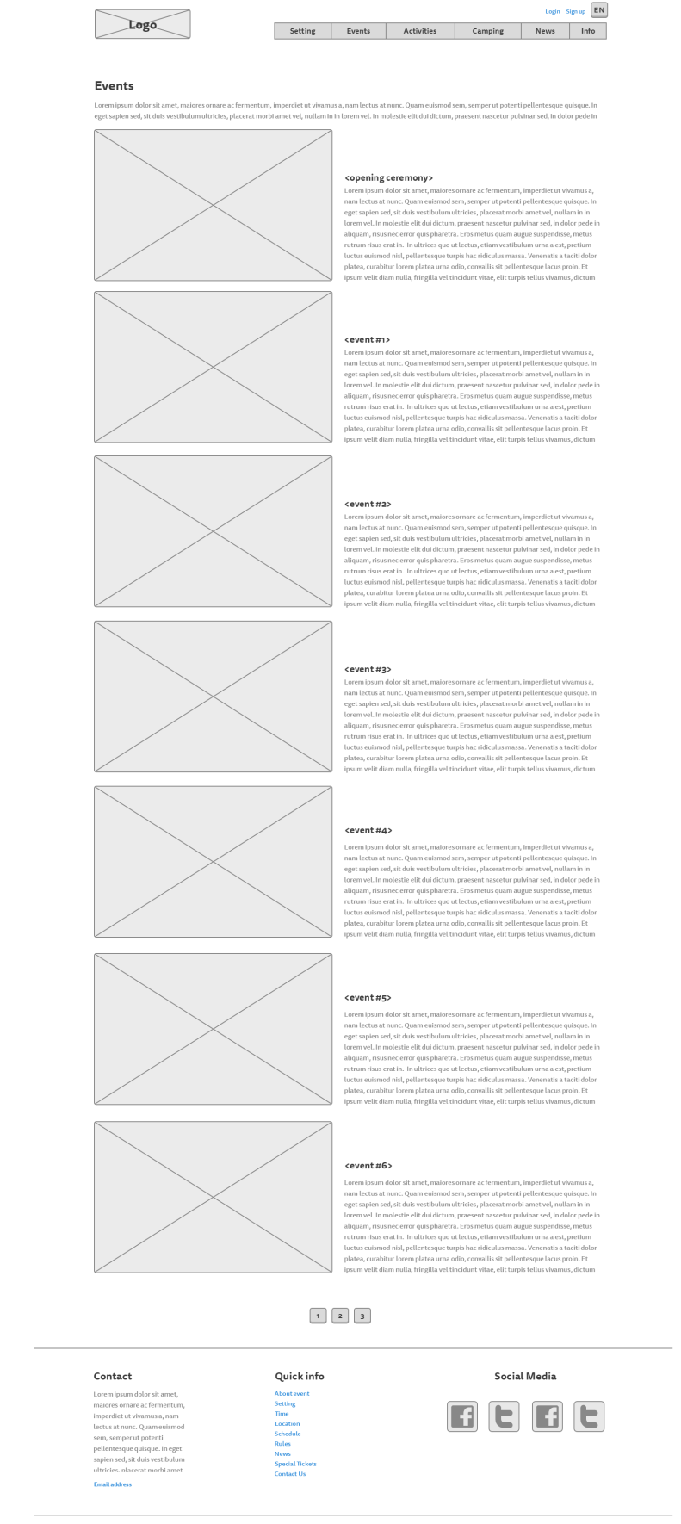

## Activities page:

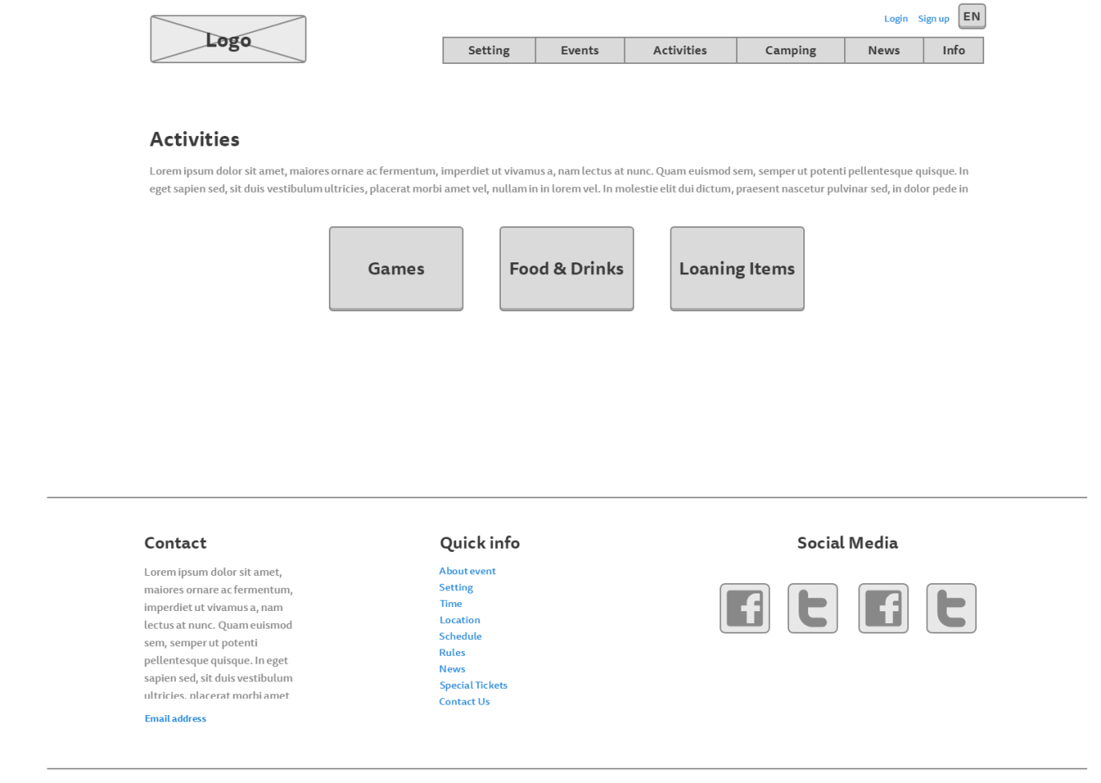

## Food, drinks and loaning items page

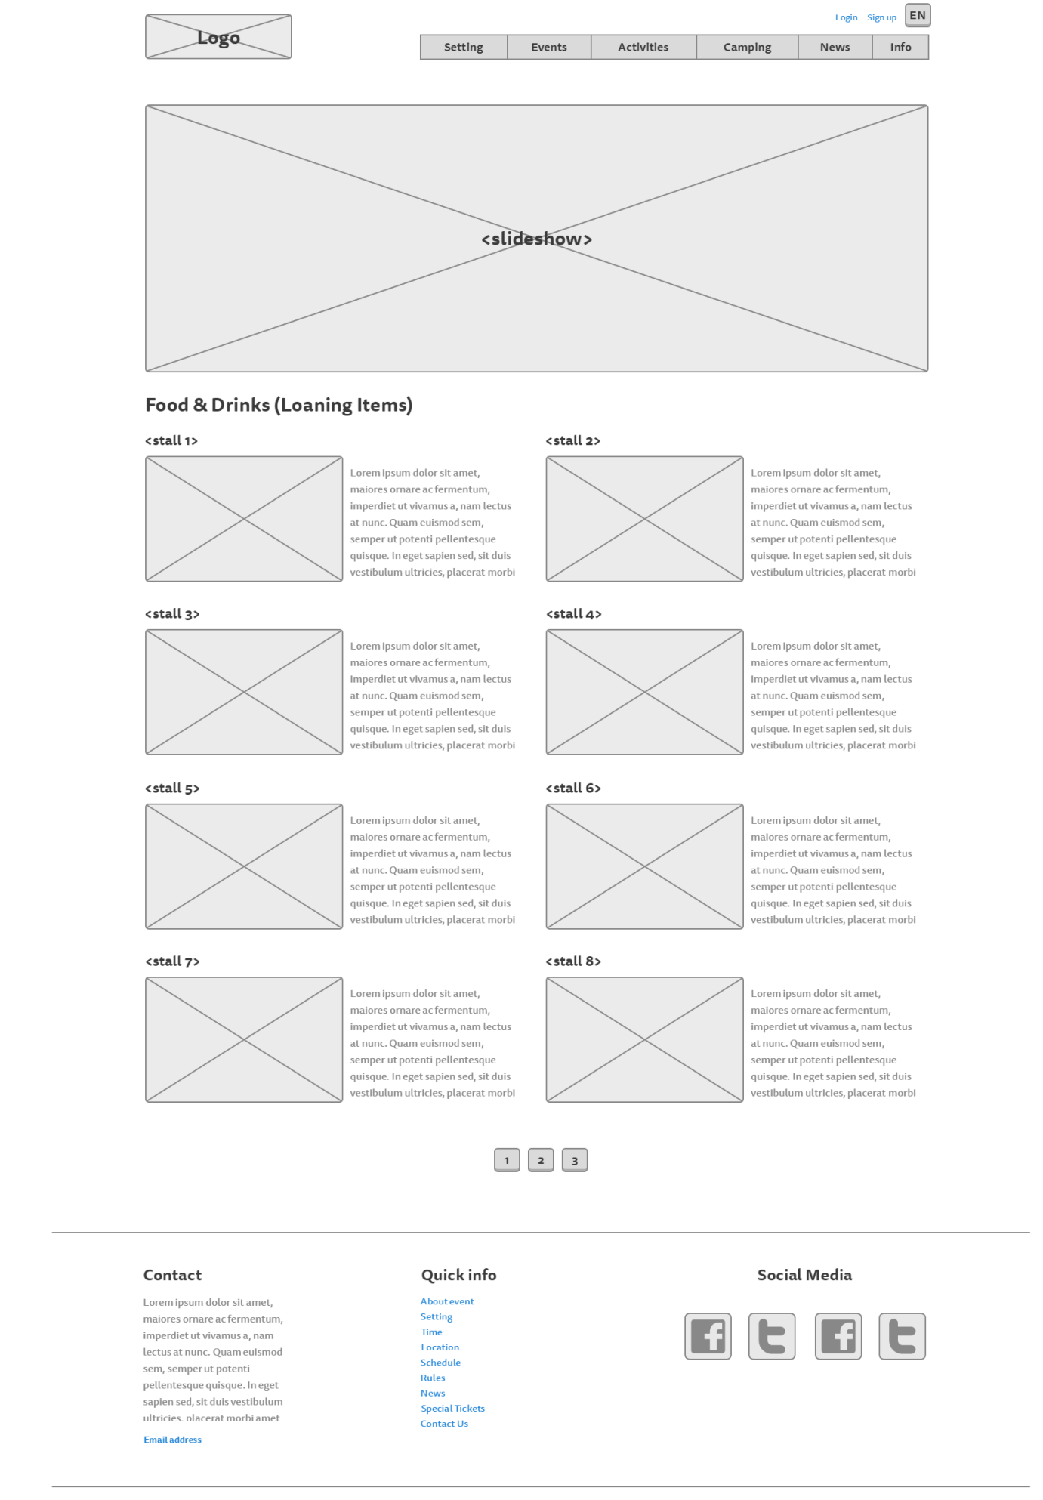

## Games page:

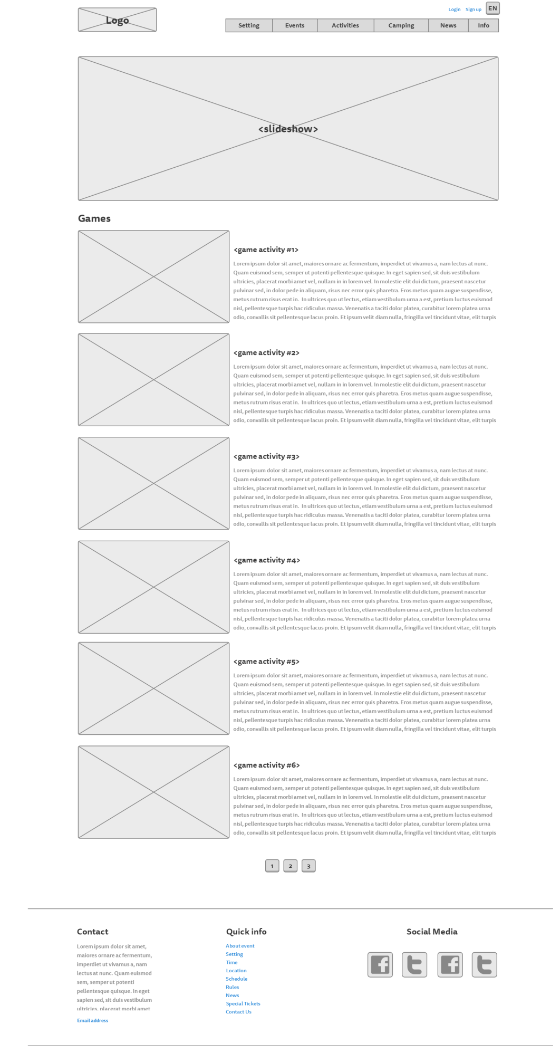

## Camping page:

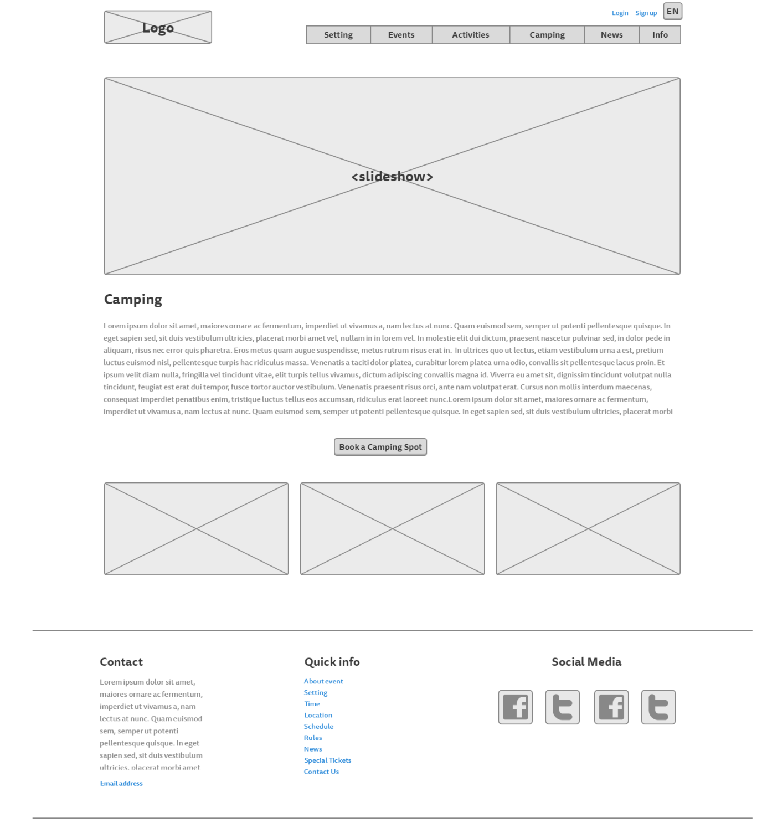

## News page:

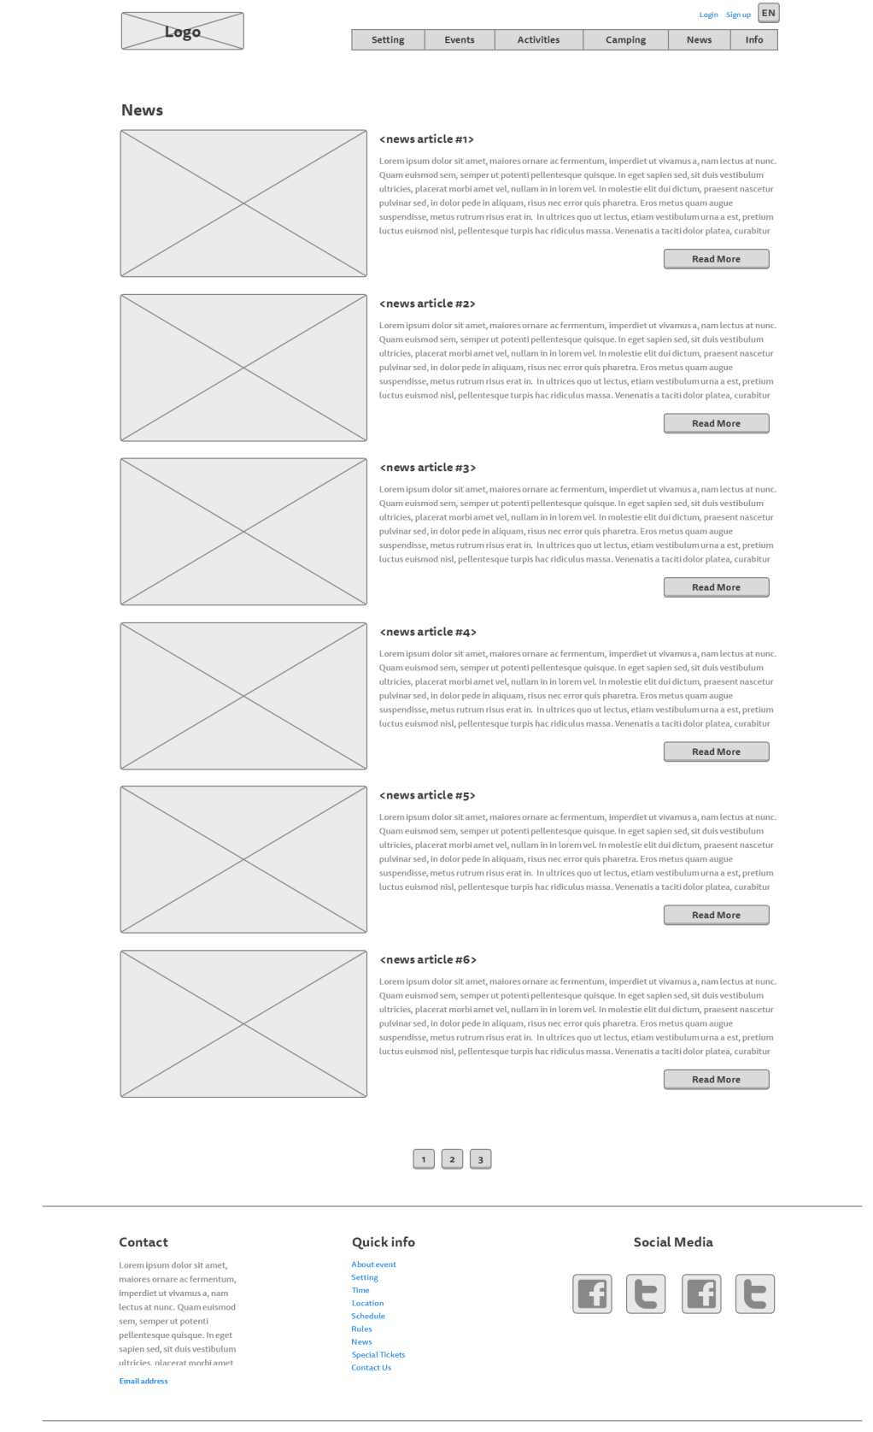

## News – read more:

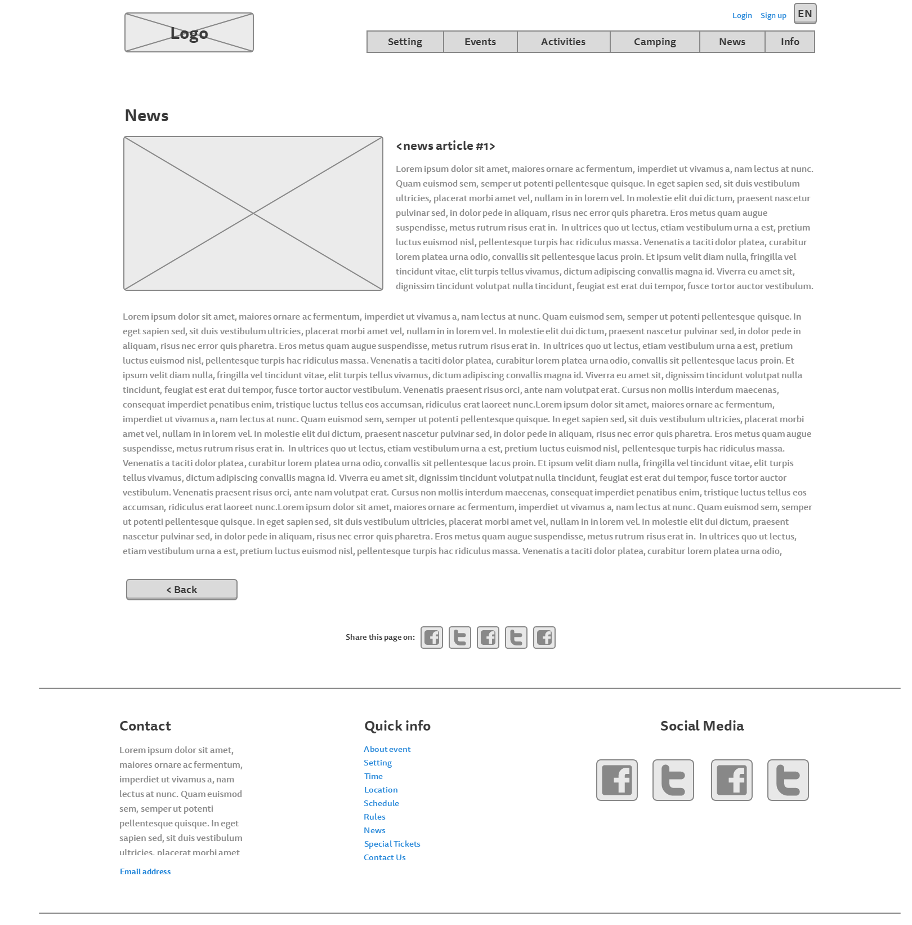

## About page:11-Info

## Login page:

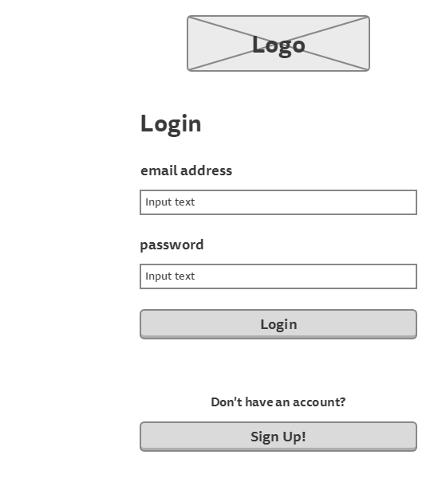

## Sign up page:

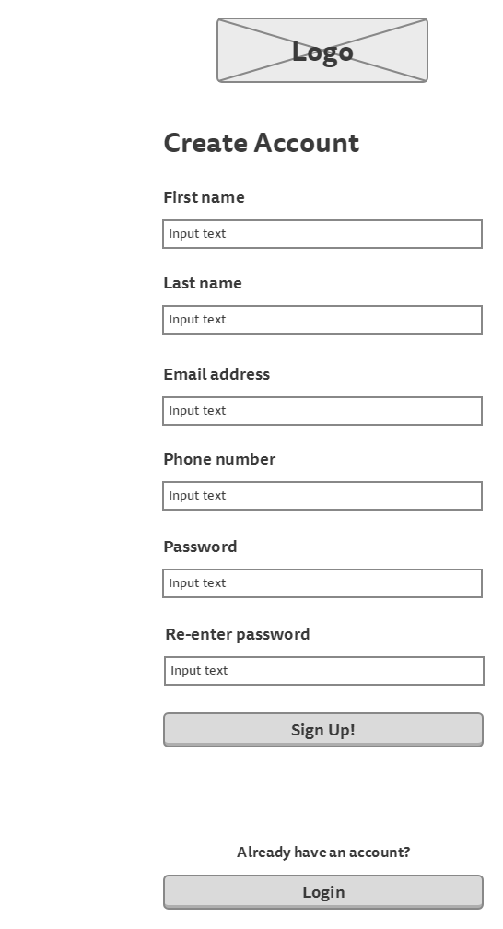

## Participant’s information page

(to show tickets information)

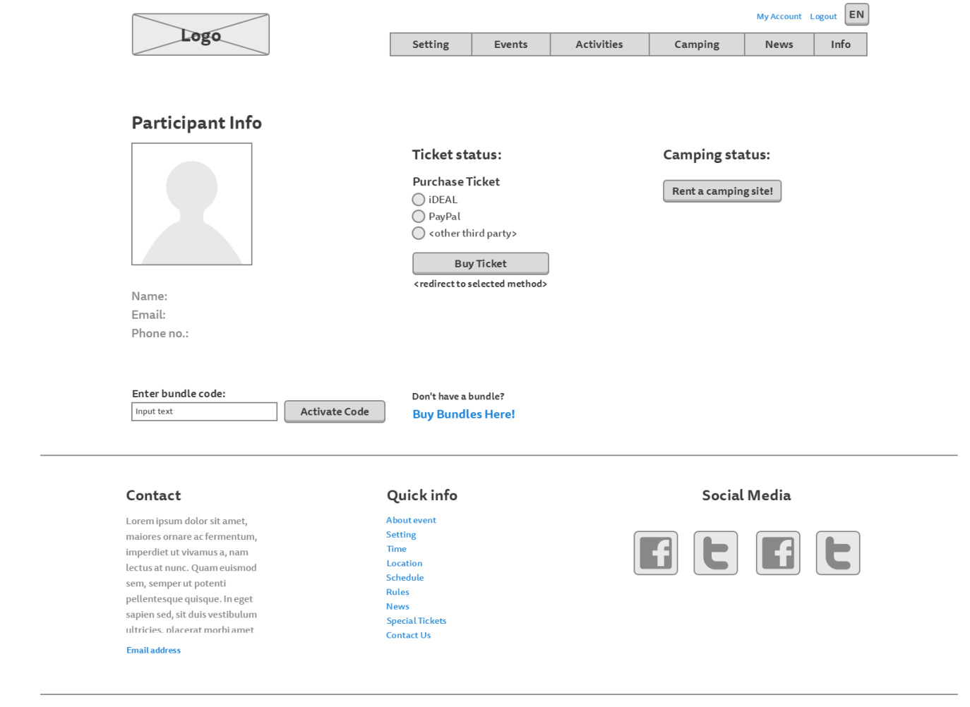

## Participant’s information page

(to show camping information)

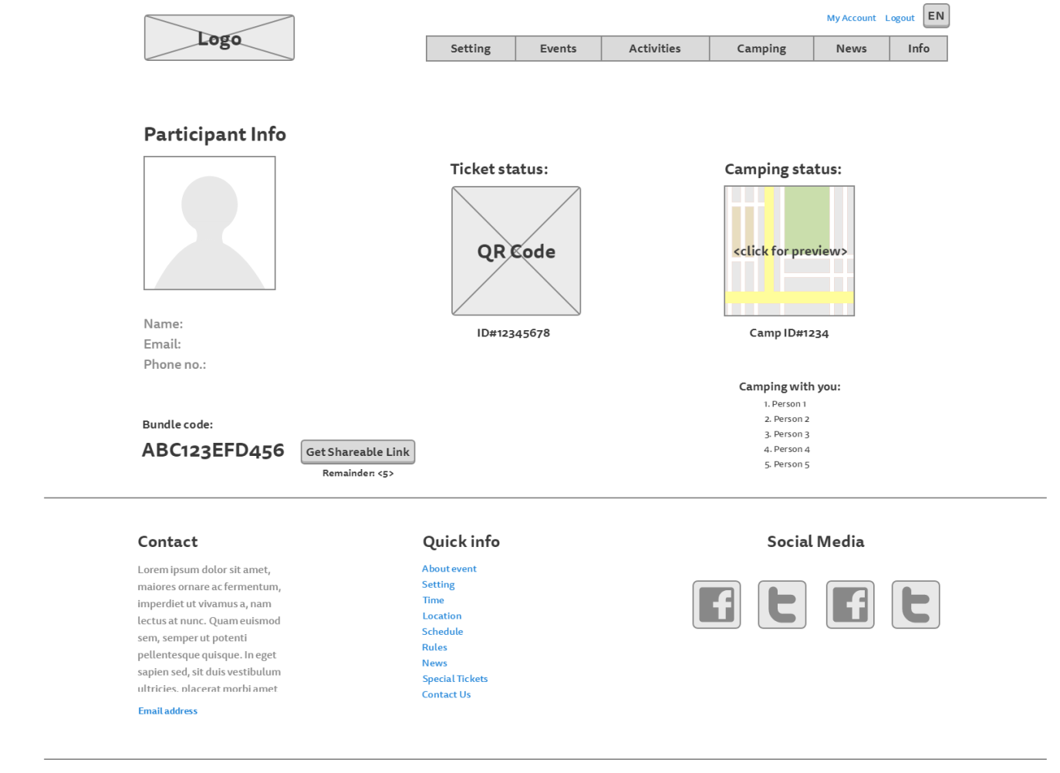

## Camping registration page:

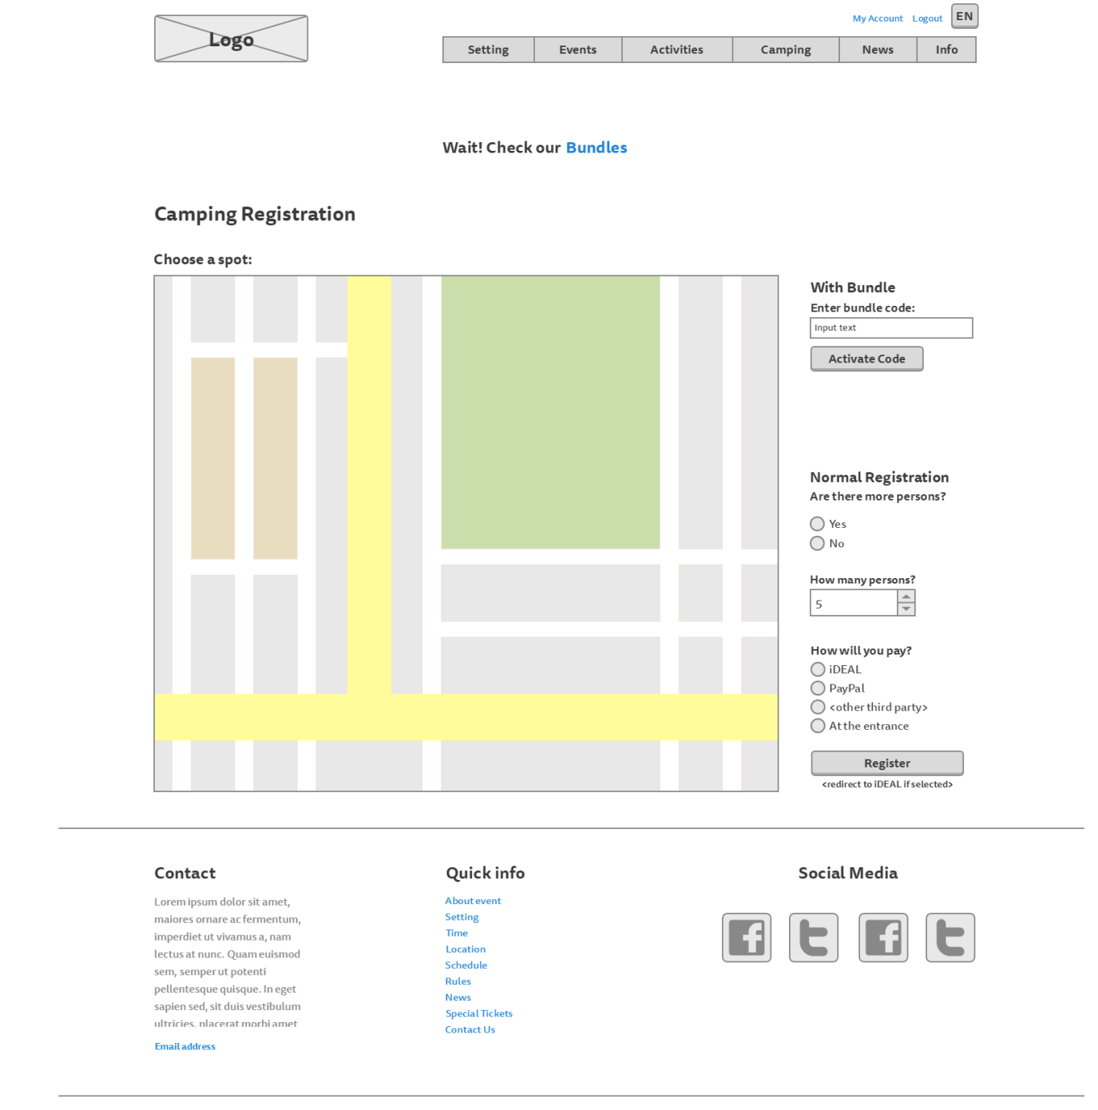

## Bundles page:

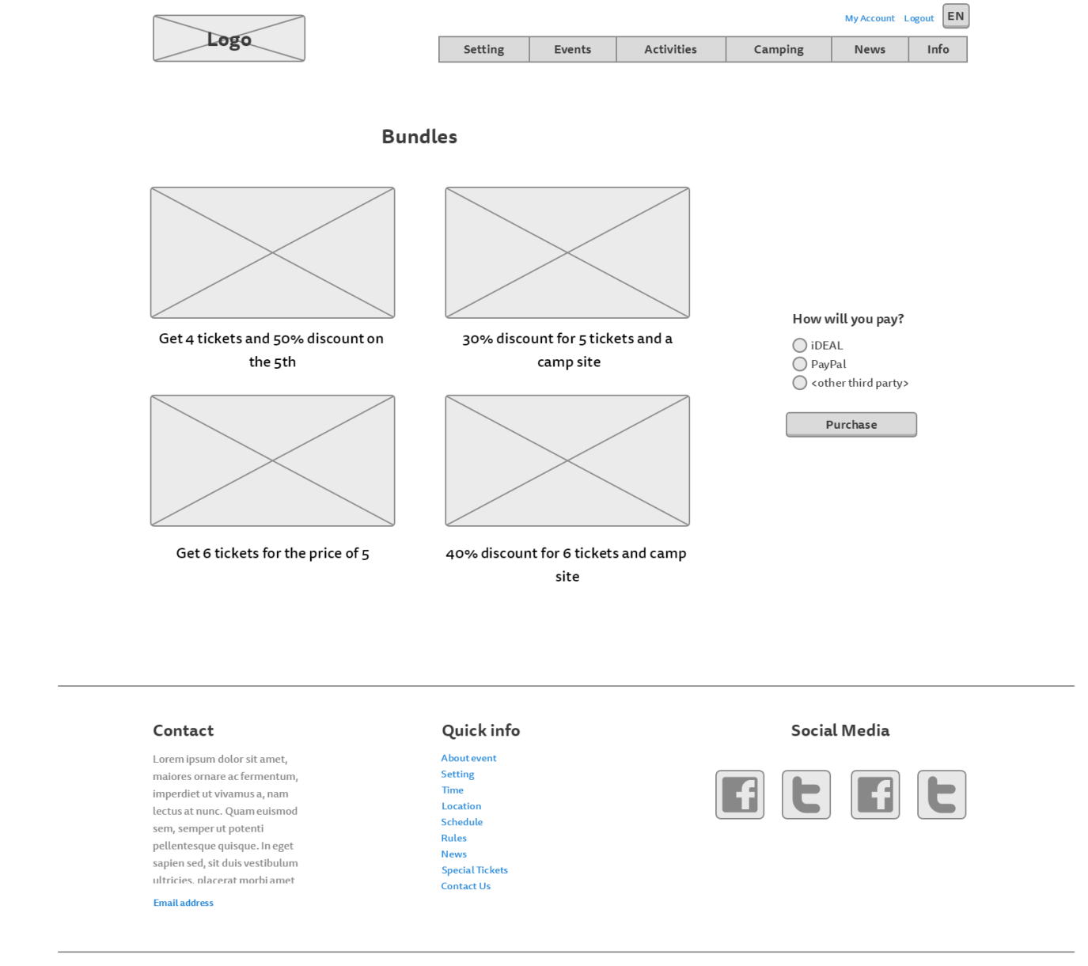

# Visual Design

## Homepage:

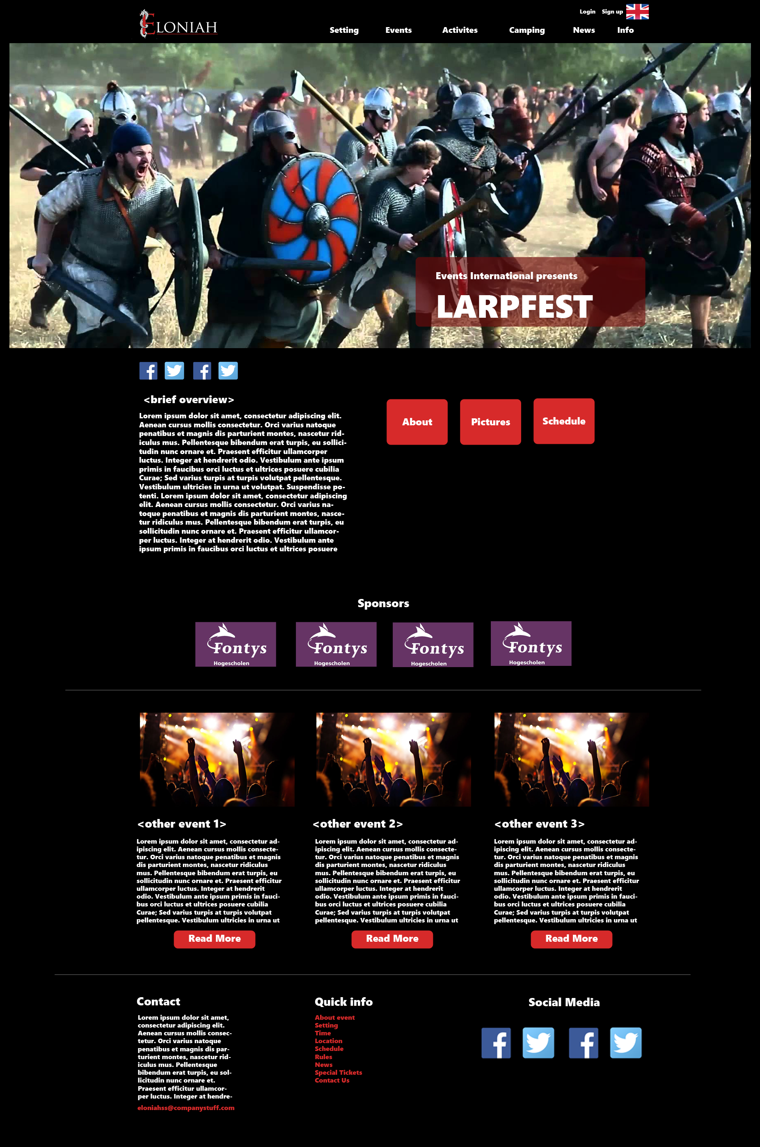

## Story So Far:

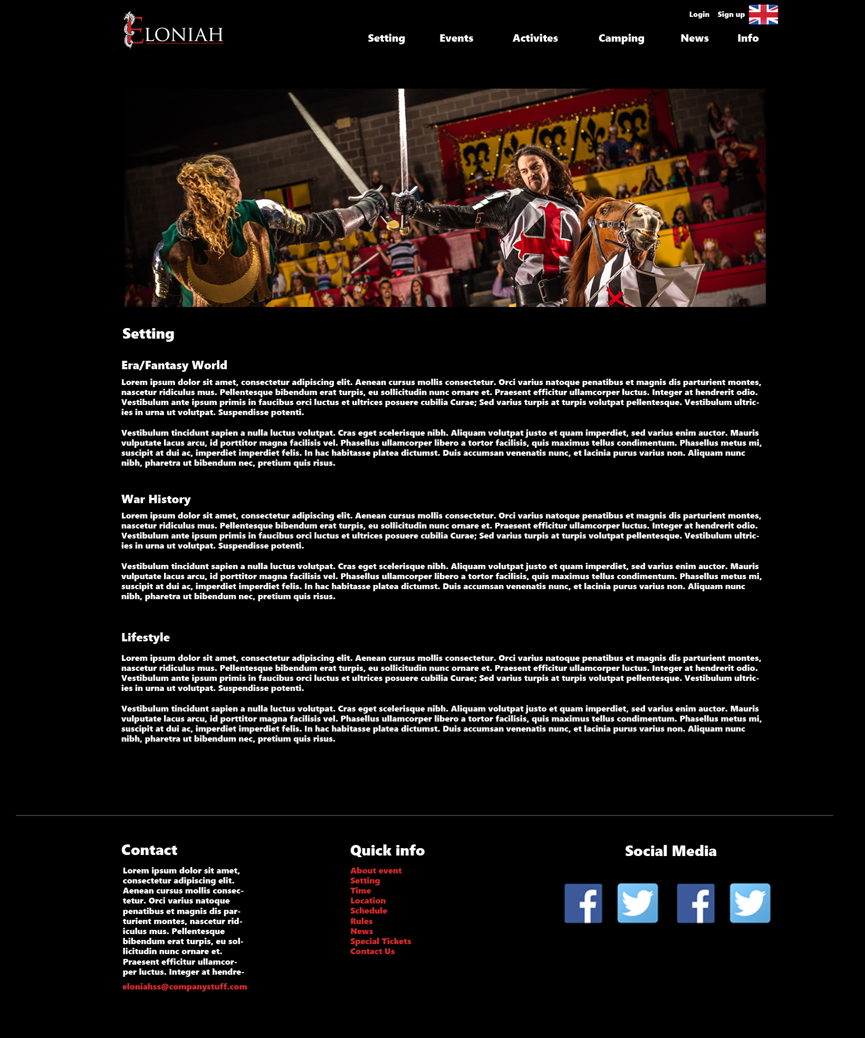

## Rules page:

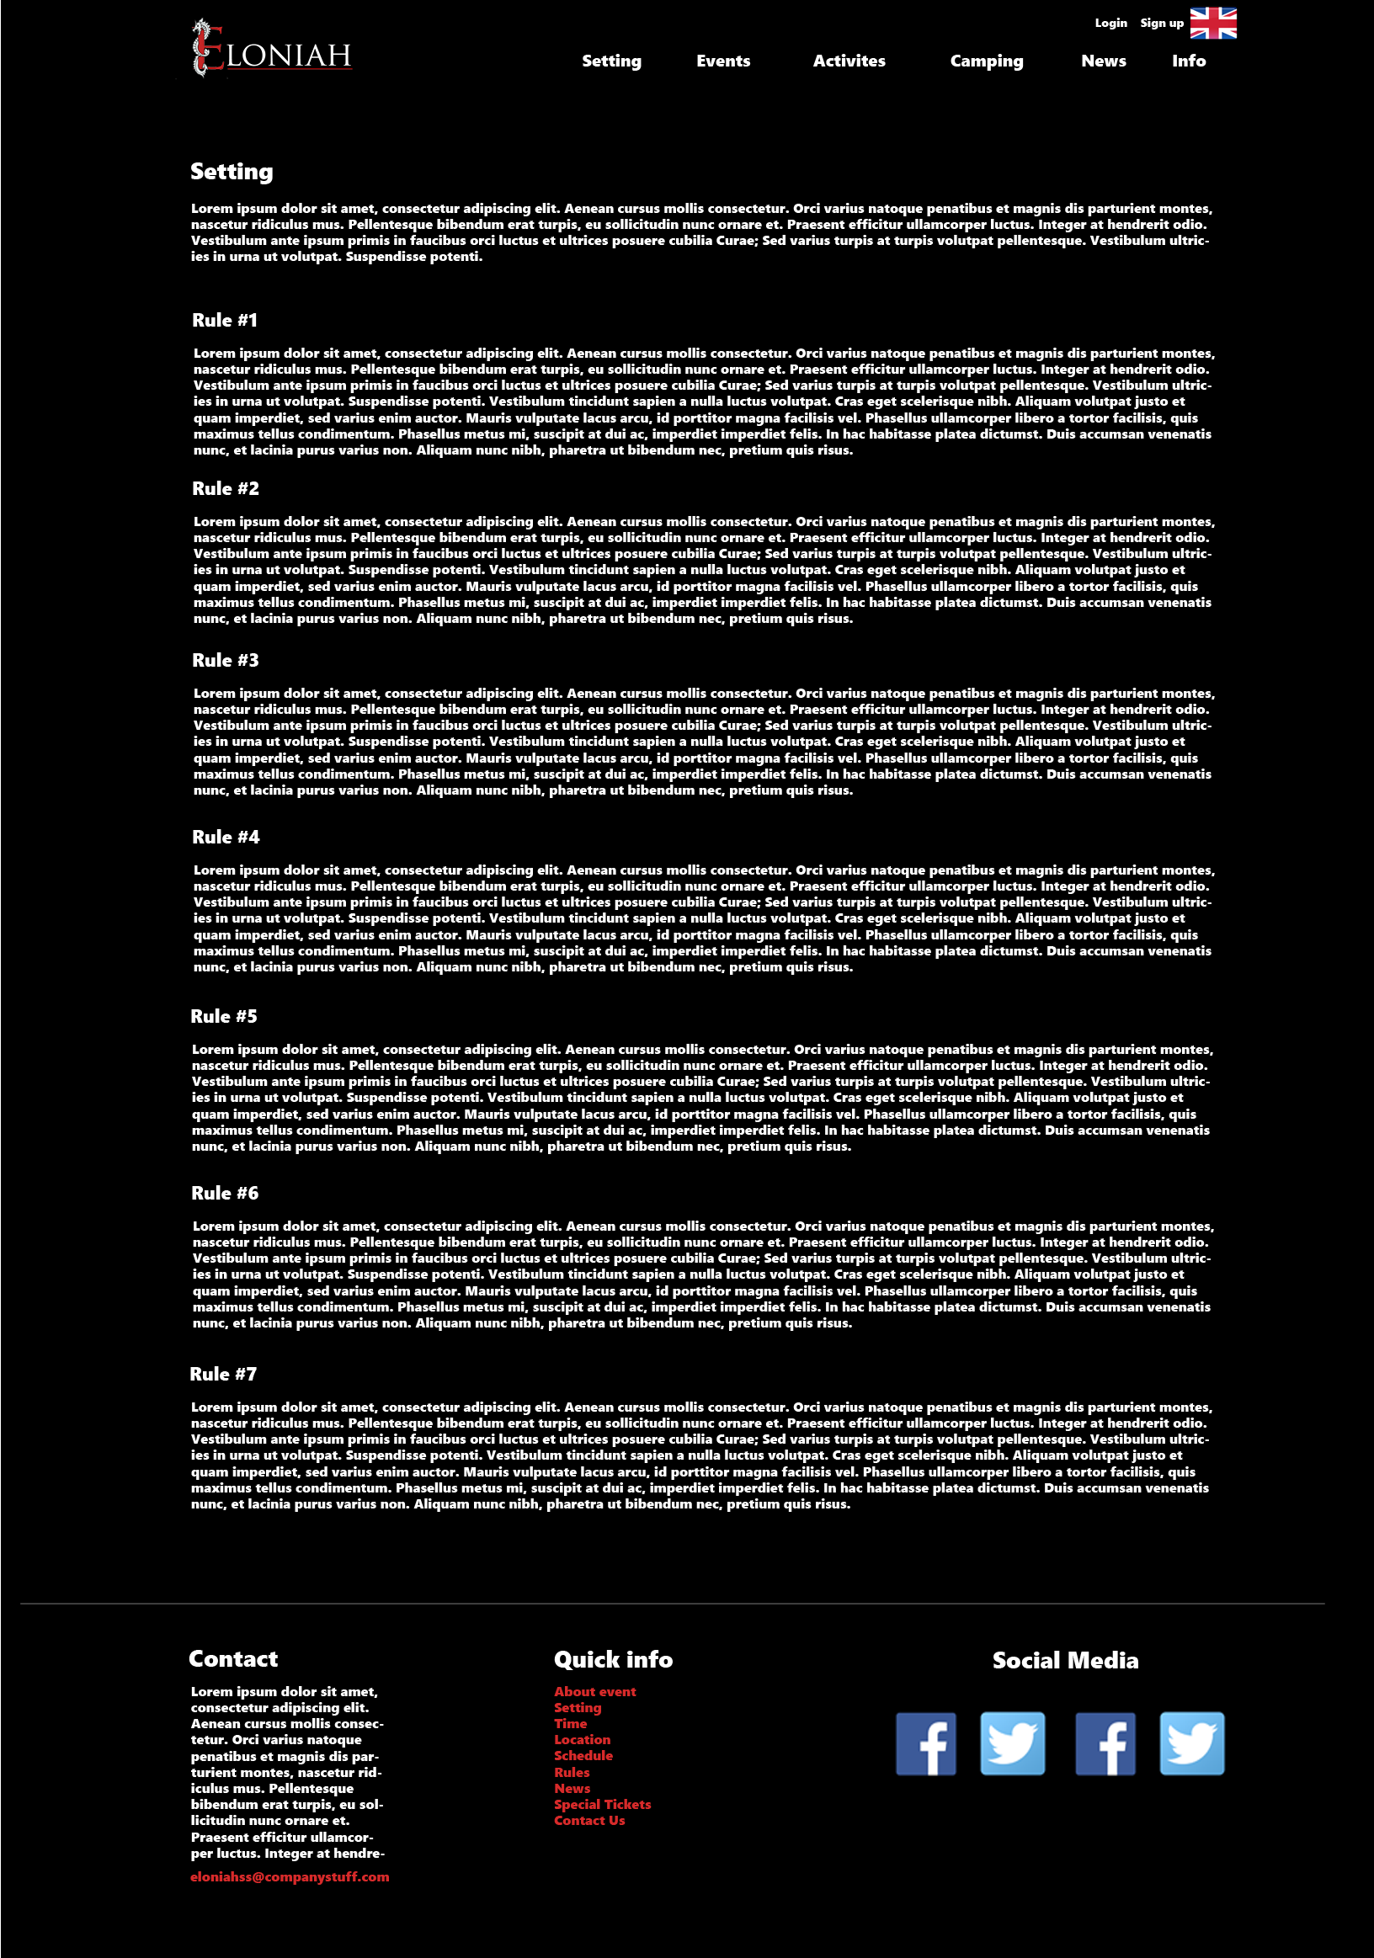

## Events page

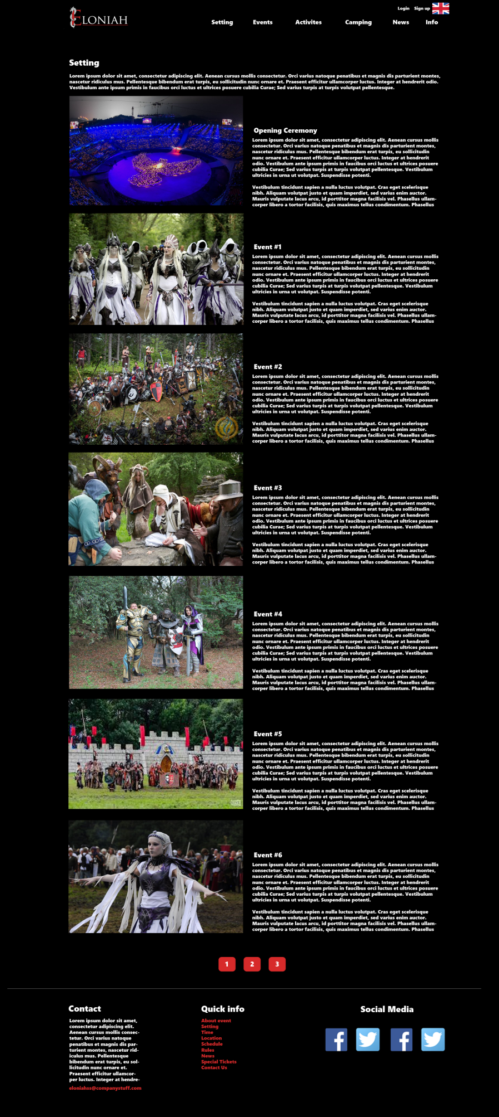

## Activities page:

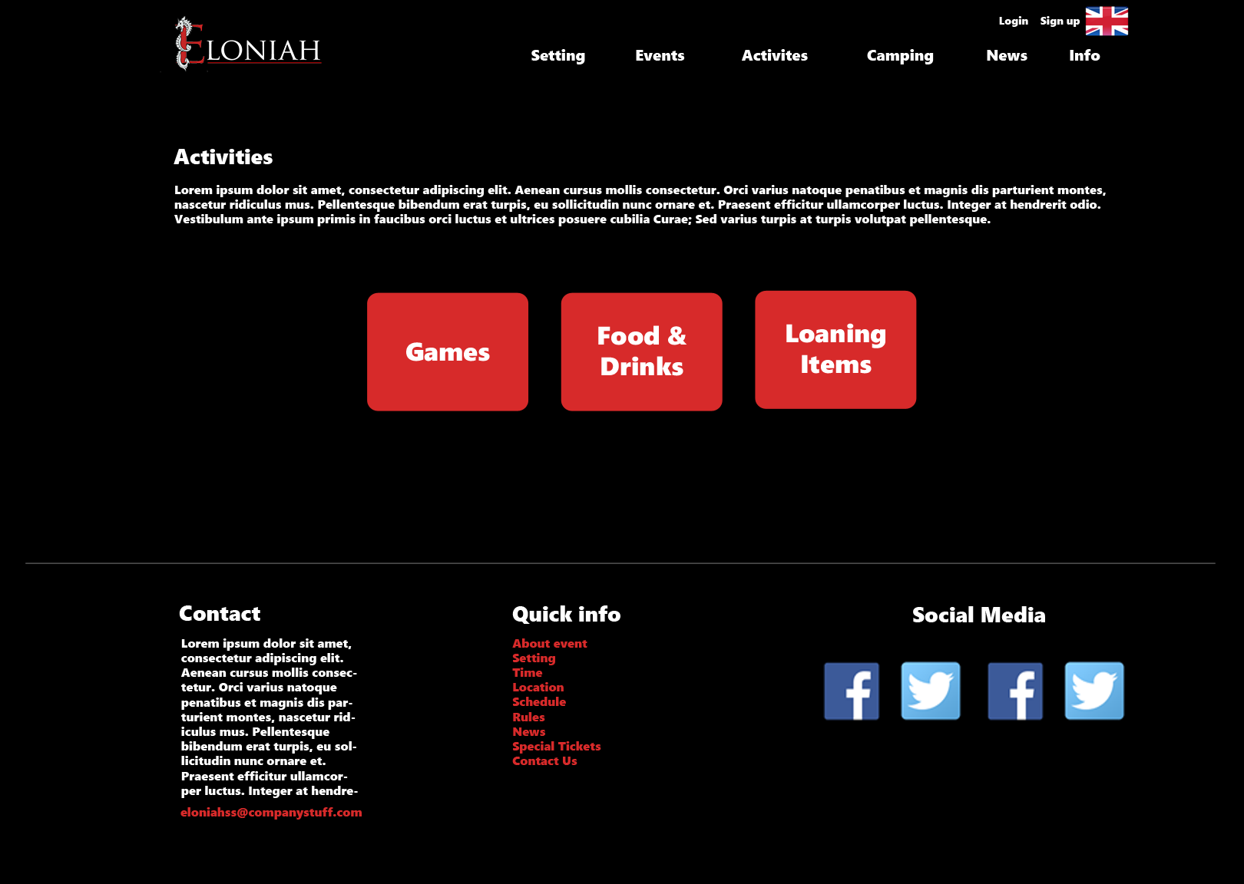

## Food, drinks and loaning items page

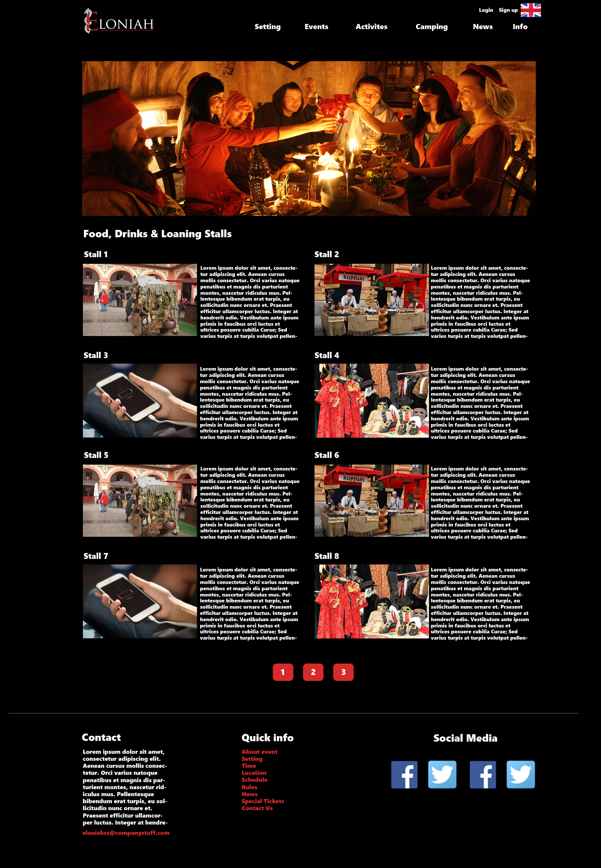

## Games page:

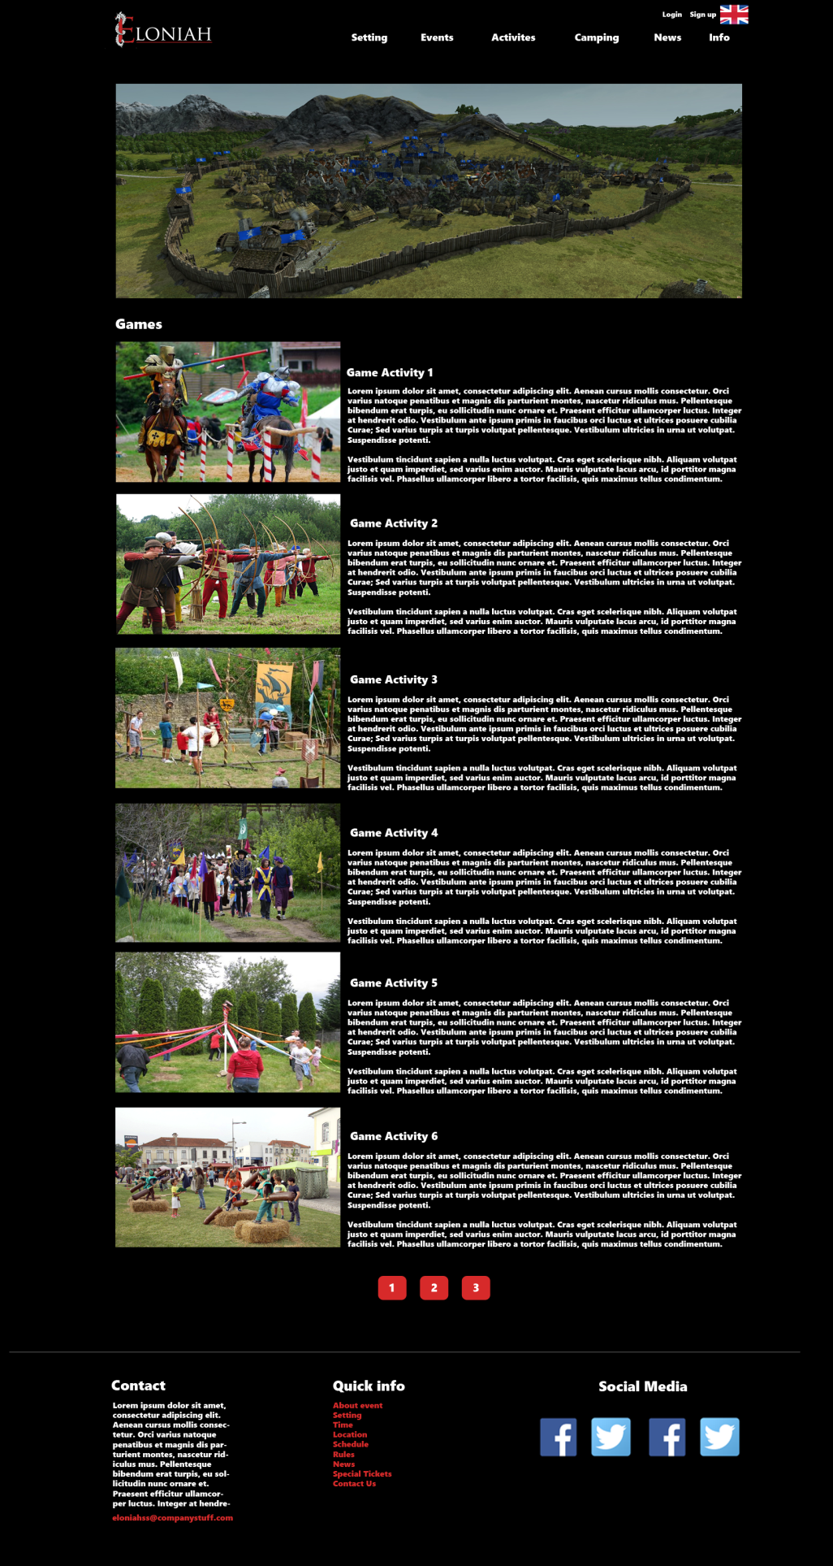

## Camping page:

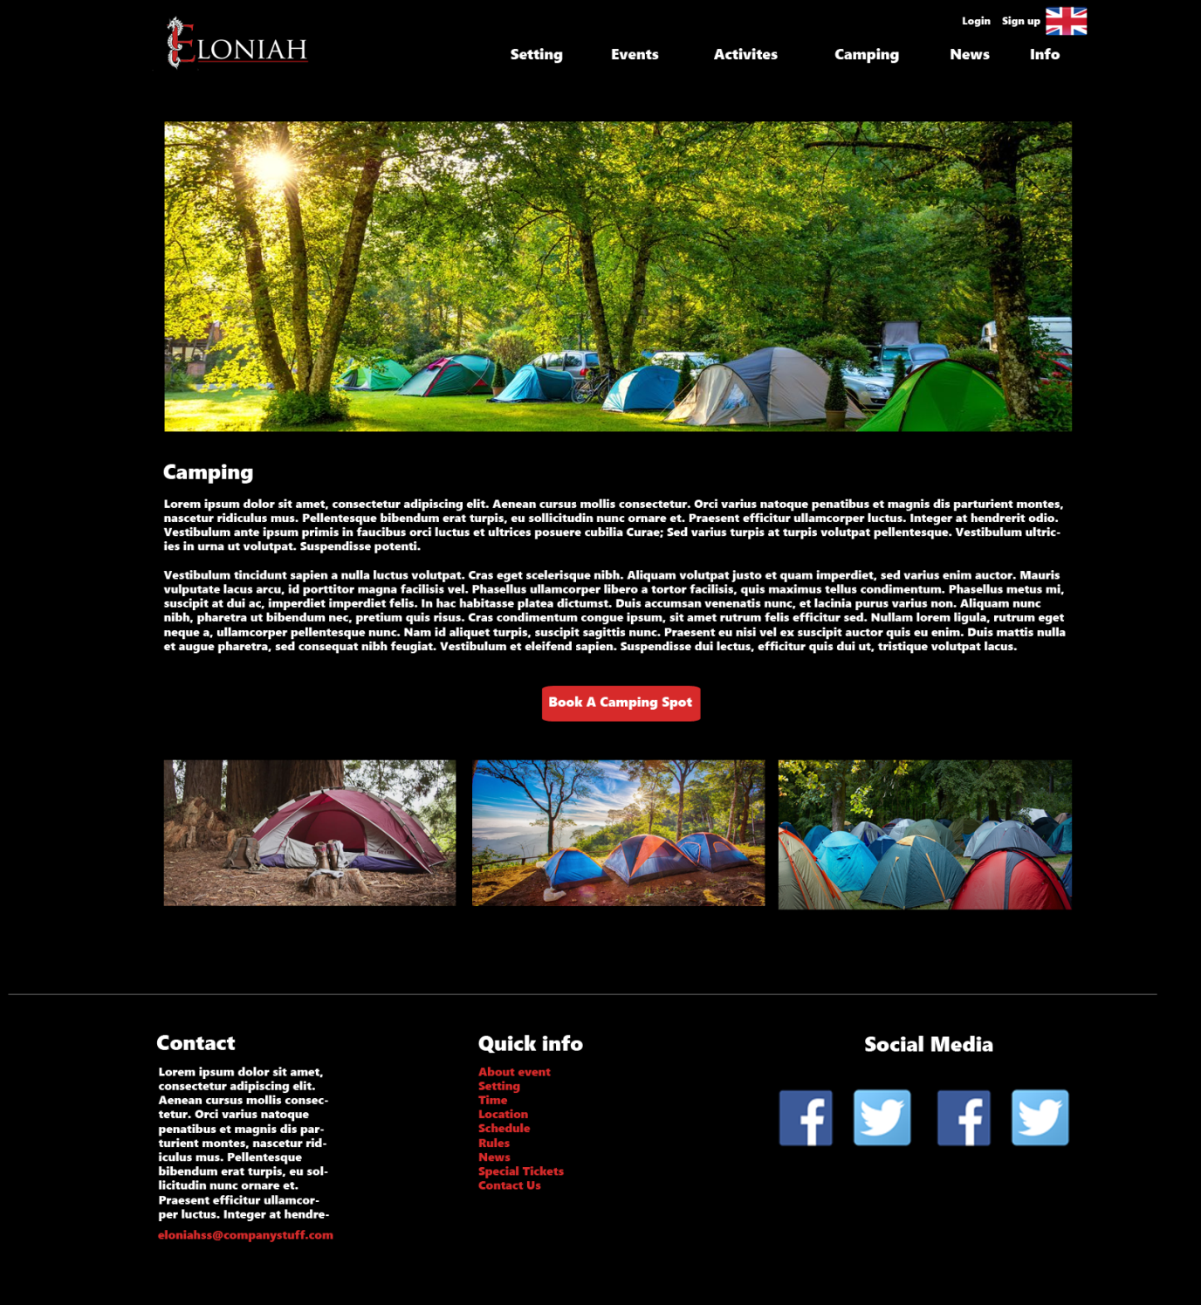

## News page:

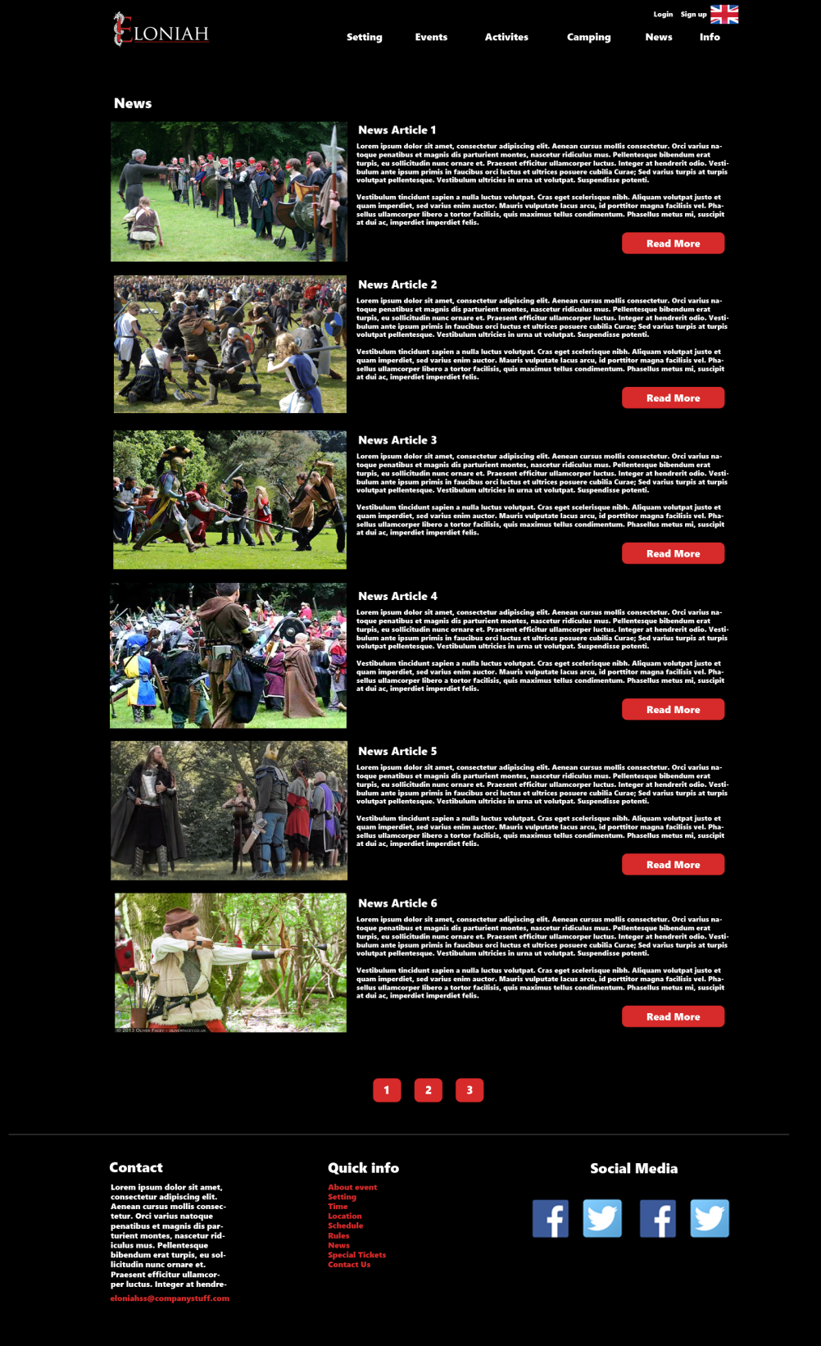

## News – read more:

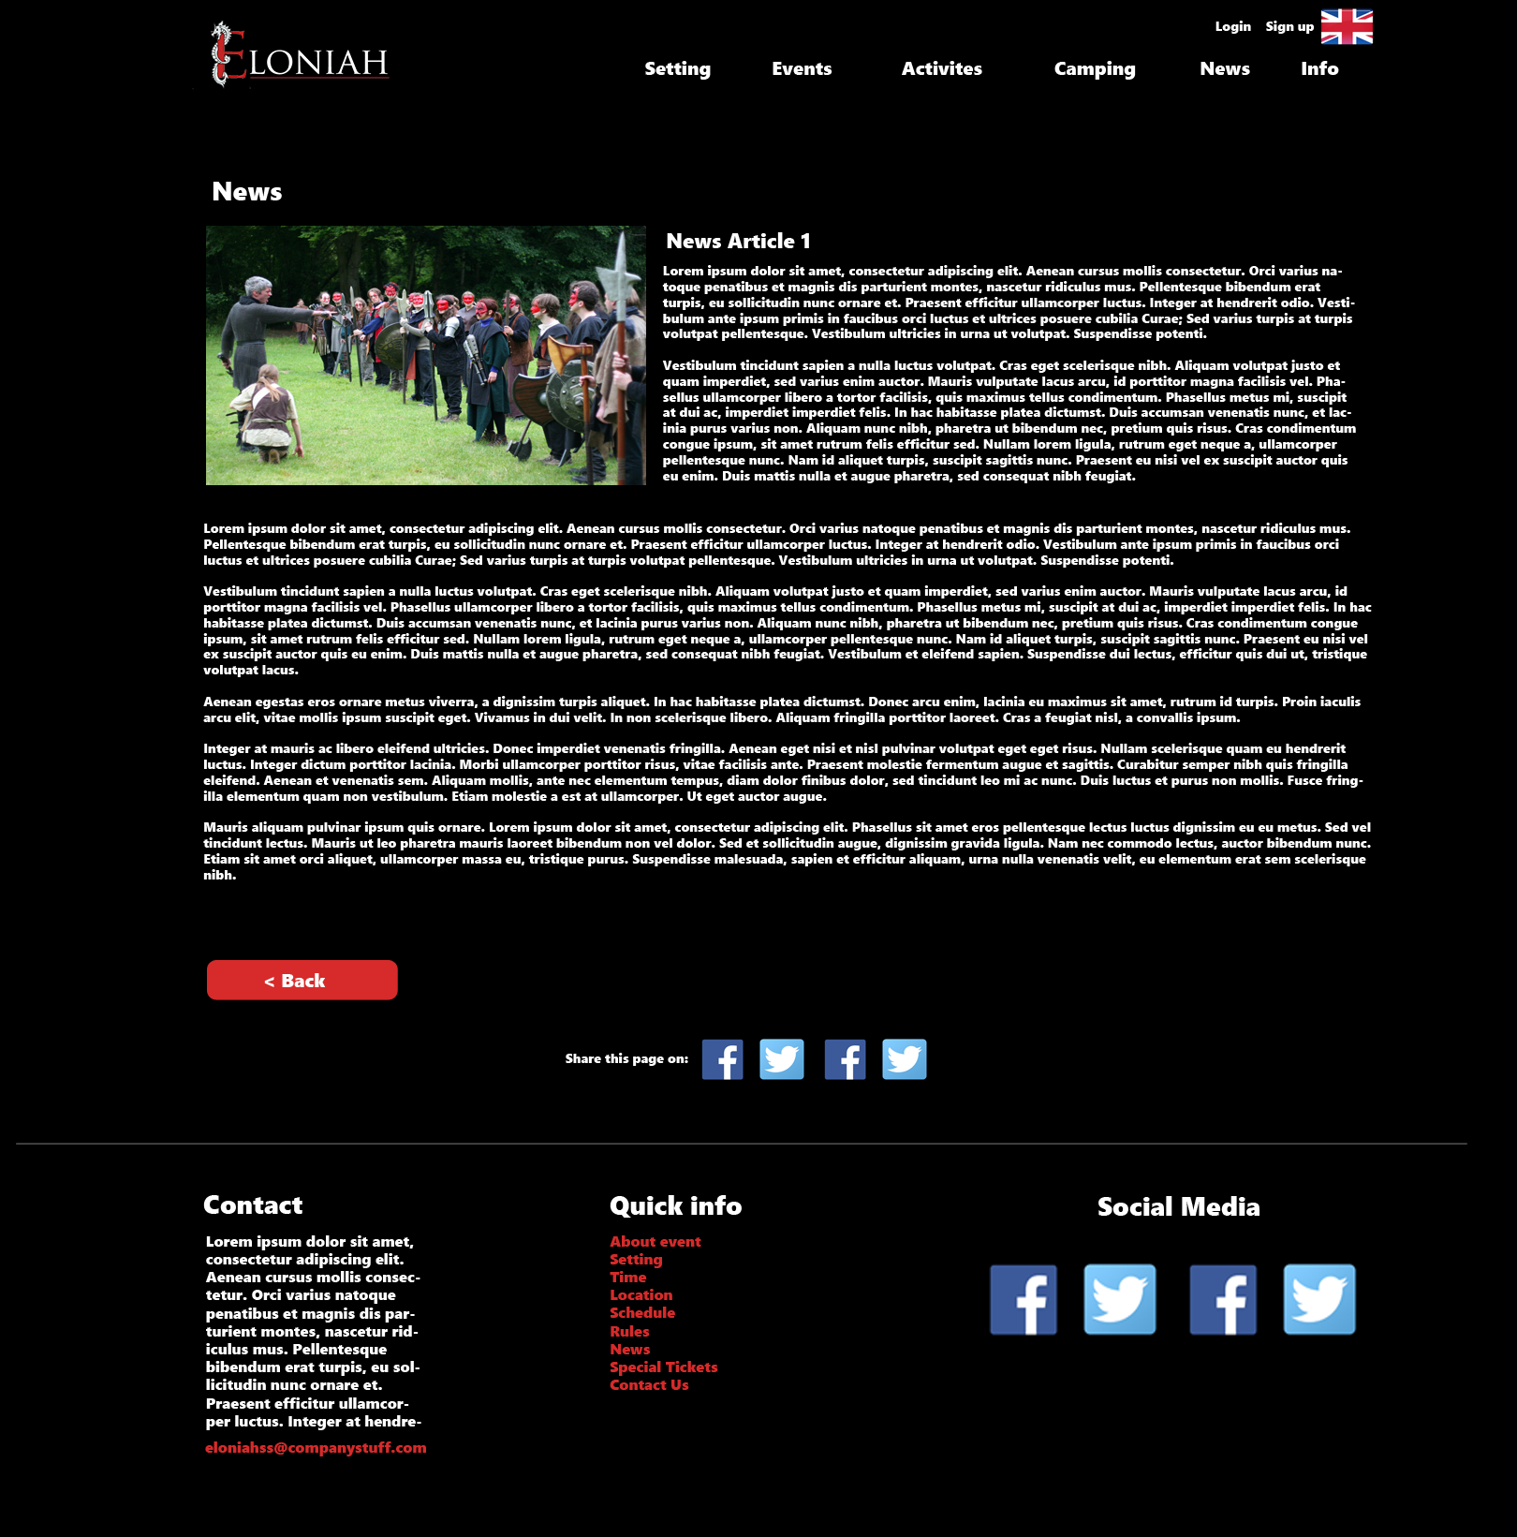

## About page:C:\Users\yenth\AppData\Local\Microsoft\Windows\INetCache\Content.Word\11-Info.png

## Login page:

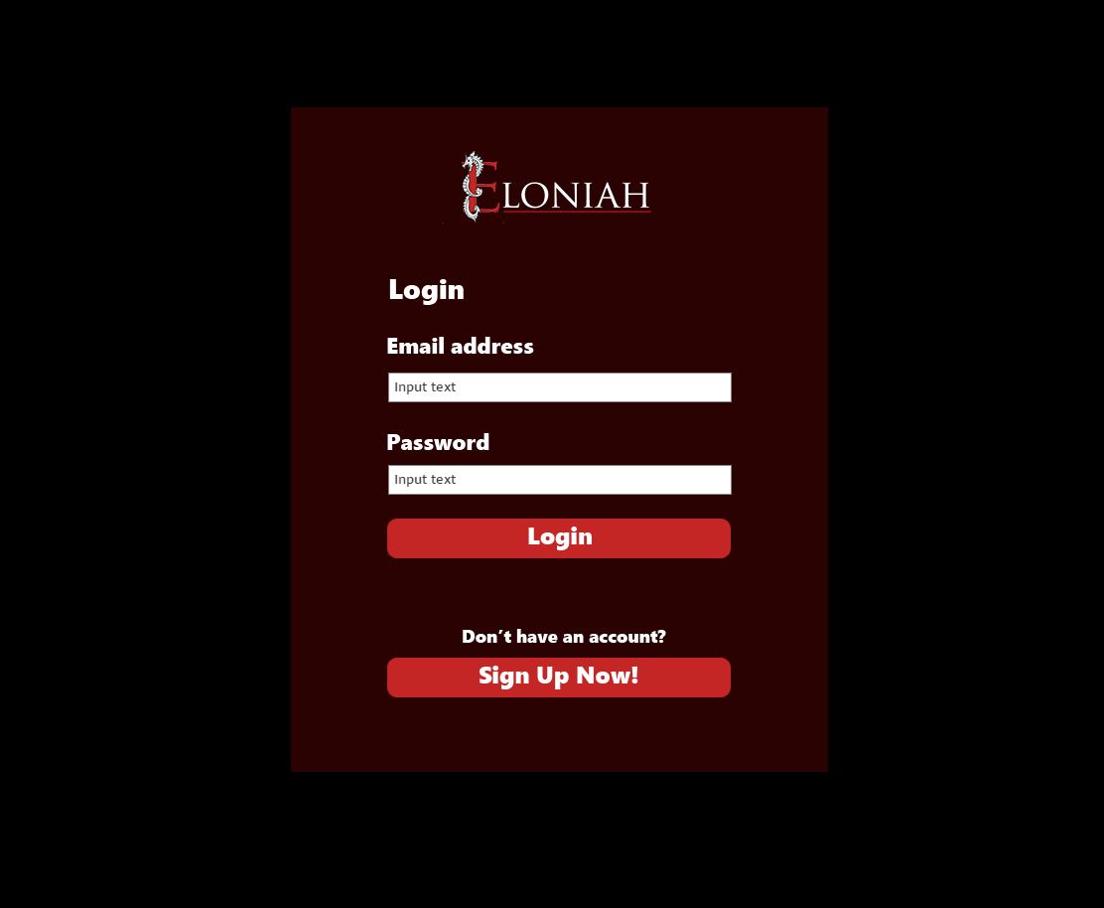

## Sign up page:

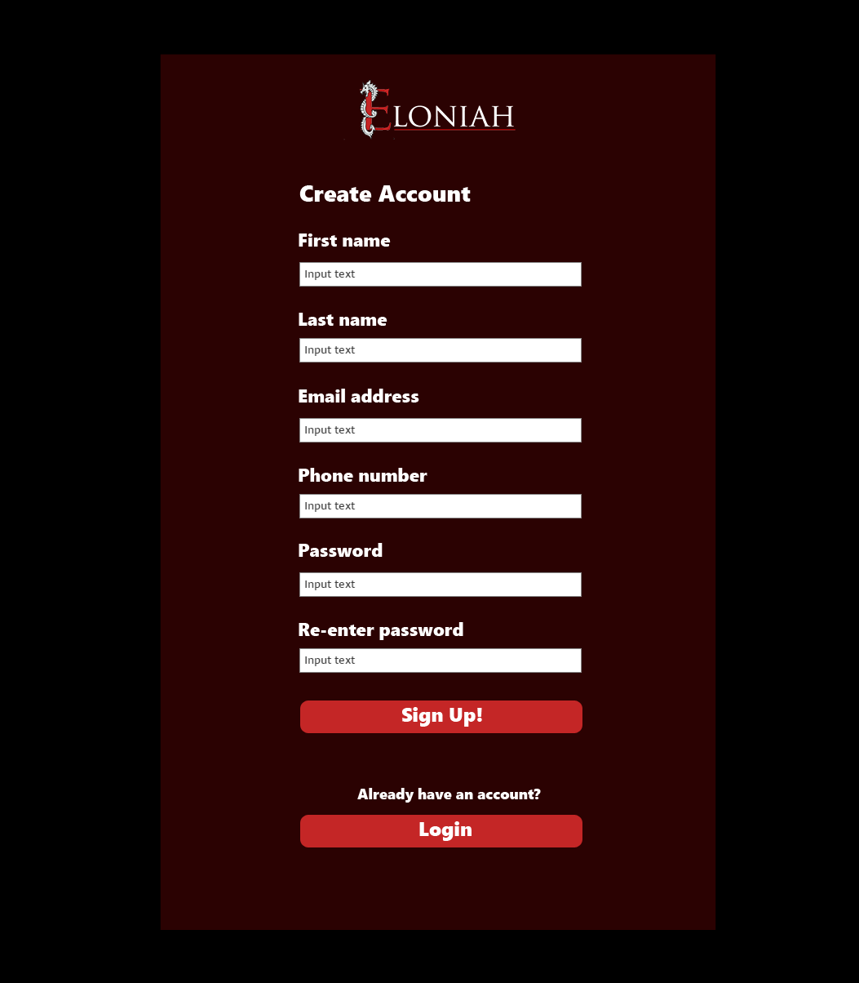

## Participant’s information page

(to show tickets information)

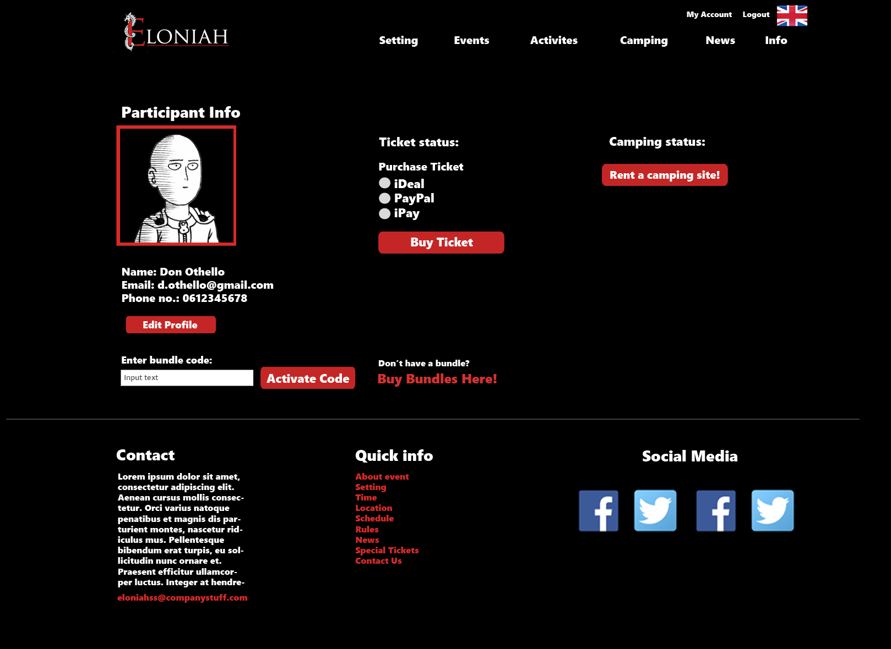

## Participant’s information page

(to show camping information)

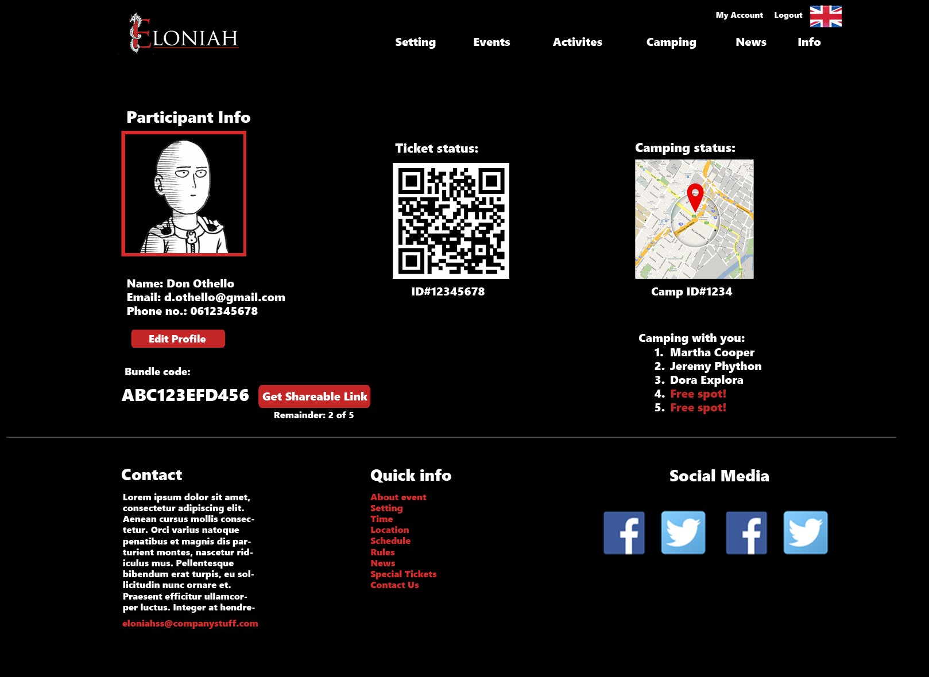

## Camping registration page:

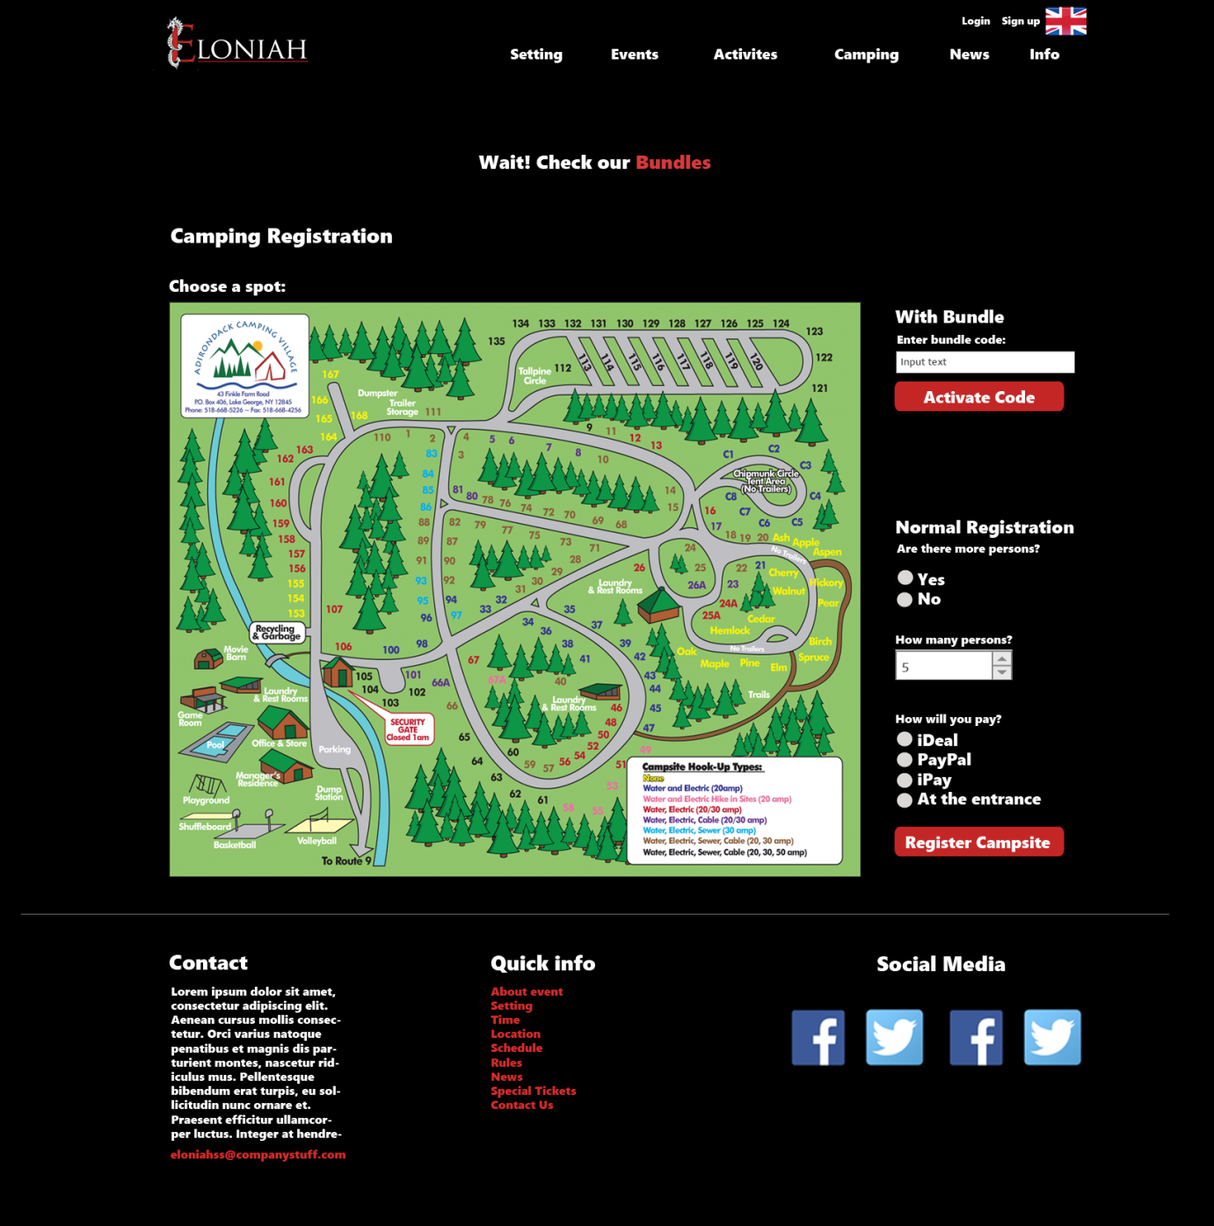

## Bundles page:

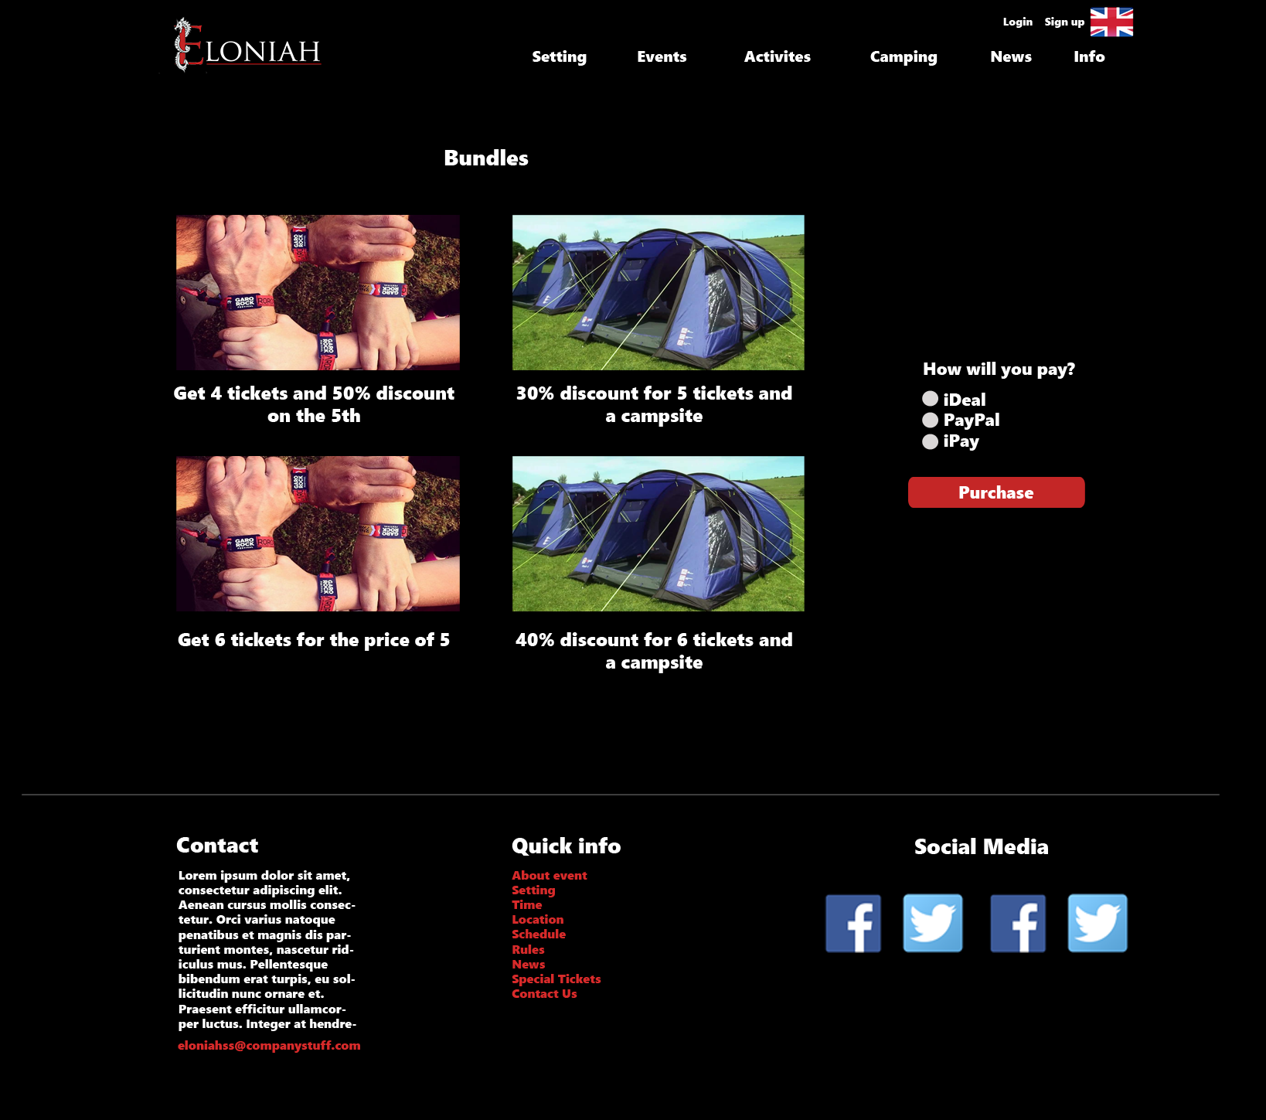

# ERD

* **Red**: The core entities.
* 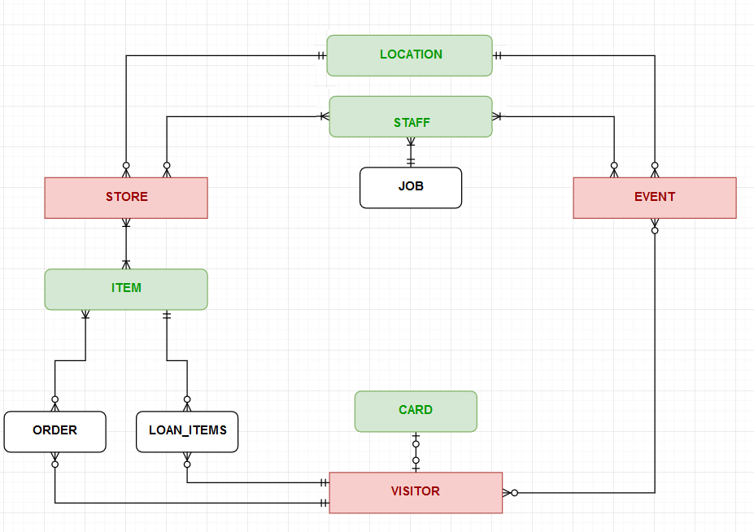**Green**: The entities supporting the core ones.
* **Black**: The entities supporting implementation.